Why is China so "red" - the choosiness of the Chinese in color use
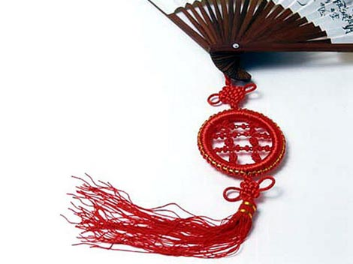

If you do not know what to wear to attend a Chinese celebration, something red is always the right choice on such occasions. The red color is always associated with "happiness and good fortune". It is symbolic of fire and wards off evil spirits. The Chinese people enjoy decorating their houses with something red, e.g. red couplets on both sides of the gate; red paper-cuts on the window; red character "福(fu)" on the door etc during the Spring Festival (the biggest holiday m China and wedding celebrations. The bride wears a traditional Chinese wedding dress in red on her wedding day (though probably influenced by the western customs she would wear white wedding dress at the beginning of the celebration). Unlike the connotation of red to anger, danger and the irrational outburst of emotions in the West, such as the expressions like: be a red rag to a bull; to see red; to see the red light; to paint the town red; red in tooth and claw etc, the red always carries commendatory implications in China. Red loving customs can be traced back to the ancient worship of the fire, which always shelters people with warmth and safety.
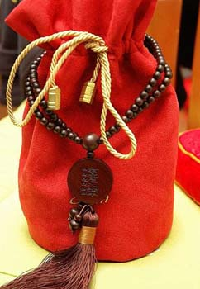
The next color used to be very special is yellow, which resembles the color of earth and soil. Since China used to be an agrarian society, earth and soil were very important to them. Yellow used to be the exclusive color used by the Emperors in China.
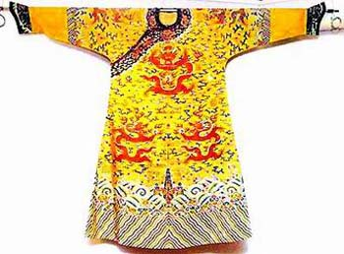
Another favorite color is green, which represents life and vitality, while black and white are associated with death. Don't wear a black dress to attend the wedding or a birthday party. Wearing white headdress indicates that someone in your home recently dies.
Probably black is also associated with darkness. The Chinese like to refer to things illegally done "black", for example, "black money" and "black market". And "black heart" refers to someone really bad.
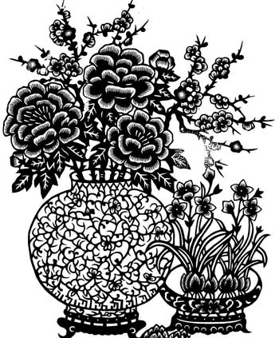
The implied meanings of colors are conspicuous in the costumes of traditional Chinese operas. Red indicates loyalty and courage; black represents integrity and impartiality; yellow apparel signifies royalty and white to purity.
Don't wear a green hat on any occasion in your daily life. "Wearing a green hat" is a Chinese idiom referring to one's wife has committed adultery. A husband wearing a green hat seems to claim that his wife is an adulteress. Therefore don't make yourself a standing joke.

http://traditions.cultural-china.com/en/14Traditions5161.html

