Draft: MC Jones

Lesson Plan: **Shifting Winds of Communist Policies, Video: *To Live***, 4-5 days

10th grade World History, Cal State Standard 10.9.4 (Chinese Civil War and the rise of Communism)

Materials: DVD, projector, *To Live,* Activities, access to internet.

For this lesson to succeed, I need a fairly cooperative class because I use frustration and chaos to make a point, and that is to show the confusing nature of communist policies on the people of China. The impact on the lives of ordinary Chinese must have been bewildering as they ascertained the various changing policies from Beijing - from Great Leap Forward, to Cultural Revolution, to Be Rich is To Be Glorious. Oftentimes a wrong thing said could land one in jail or lead to fatal consequences.

This lesson introduces my class to post WWII China, its government, and its various socialist attempts at a utopian society. We conclude with a viewing of the Zhang Yimou film, *To Live.* This film shows in expert detail the capricious fortunes of a family living through these times.

Overview:

Day 1 – Introduce students to chaotic and confusing grading procedures. Show favoritism to random students, punishment to others. Read a short history of 20th century China. **Activity #1** is to create a timeline of events, with acceptable art.

Day 2 – Introduce film and the characters. Assign question from **Activity #3** to small groups. They will be responsible for presenting to class. **Activity #2** is to prepare a diary entry for Fengxia, wife of Fugui.

Day 3 – Continue film. Review characters, answer questions of continuity and possible diary entries.

Day 4 – presumably we are finished with film. Students present their answer from activity #3 to class. Show/explain propaganda from site online, **Activity #4**. Turn in other activities.

_________________________________________________________________________________________________

**Shifting Winds Of Communist Policies**

**Day 1:**

1. This activity is designed to introduce students to the feeling of living under changing government directives in communist China. You must have tolerant, cooperative students for you are going to become erratic and provoke anxiety.
2. Have some sort of reward available: candy, tokens, cards. Arrange desks to reach students easily.
3. Tell students you are introducing a new grading system and need their input. Rewards will be given for convincing, well-thought arguments.
4. Write this on the board: *“To promote cooperative learning, should I adopt a grading system in which every student in the class receives the same grade based on averaging the performance of all the students?”*
5. Respond to disagreements curtly and dismissively. Become increasingly tart and abrupt. Reward well-reasoned agreements lavishly. Do not reward passive or limp agreements.
6. After 5 minutes or so, change the rewards altogether. Punish agreements; declare you are looking for correct arguments. Have fun. Then shift back.
7. The students will become bored, exasperated, and point to others as sell-outs. (Goal!) After 5 minutes, shift again. You will lose them, they won’t care anymore, they’ll do anything for a reward.

You were kidding about the grading system. But ask them a few questions:

1. How did you feel about being asked for input?
2. How did you feel toward me?
3. How did you feel about classmates who changed their minds?
4. How would you describe the atmosphere in the room during this exercise?

Tell them this activity was to help us understand the emotions and anxieties surrounding the abrupt changes in Communist China.

Read corresponding material in their text, or use this (below) for a short history of post war China: *Shifting Winds Of Communist China.*

**Activity#1:** Recreate timeline but add appropriate art, cartoons, photos from web, etc. (9 altogether, 1 for each event)

_______________________________________________________________________________________________

**Day 2 – Watch Video.** *To Live* is subtitled. Be prepared for some difficulty regarding that, i.e., help with the long bits. Have them describe meaning of title, use of irony, and what one would sacrifice for family, and proper women’s roles. But keep it short, get to the film.

**Activity #2 -** Write a diary from the point of view of Fengxia. What are her inner thoughts about the events that happen in her life? Have students notate enough during the film, but not enough to distract from the continuity of the watching experience.

**Activity #3 –** Divide class so that there is one question (9) per group. They will present their findings to entire class.

**Watch Film**

**Day 3** – Continue film. Review briefly the plot and assignments.

_________________________________________________________________________________________________

**Day 4 –** Continue film. At this point introduce propaganda posters from website. (optional if you would like them to draw one**)**

Continue film till conclusion.

Wrap up: After Viewing the Film

1. Provide time for students to analyze the information they have recorded on their Reviewer's Form. Ask students to share their responses in a discussion structured to offer critical review of the film

2. Ask students what they learned from the film.

3. Have each group present their project or findings from Activity #3, #4 to the class.

**Activity #4**: Propaganda posters.

Propaganda posters became a prevalent form of social indoctrination and a sanctioned form of artistic expression from the 1950s until the late 1970s. Ask students to describe the scene depicted in the poster in very concrete terms first. For example: I see a working man carrying a bucket, a woman wearing red, also working and smiling, and a large building under construction in the distance.

Next, ask the students to imagine the purpose of any poster. Some posters have captions, others do not. Having determined a probable purpose for the poster, ask students to analyze what might make it effective as propaganda for a social campaign.

Have students compare a number of posters. What common aspects do they perceive? Access the following websites, or print a selection of posters from the website.

http://www.iisg.nl/~landsberger/crc.html http://www.iisg.nl/exhibitions/chairman/

(optional) For an assignment:

Activity #4: Art and the Art of Propaganda

* Pretend that you are a cadre sent down from the city to gain support among the peasants for a new social program. Or, select one of the scenes in the film to publicize. Write slogans and create a visual aid.

* Pretend that you are a Chinese peasant living in a rural village during the 1950s or 1960s. Design a propaganda poster that reflects your demands or indicates your support for government programs.

This is a 5-day assignment for me mainly because I discuss the film and the director’s attempts at narrative. The students can be very curious and/or confused by the subtitles.

I hope you are more efficient!

**Activity #2 Timeline**

**Reading: Short History of 20th Century China.**

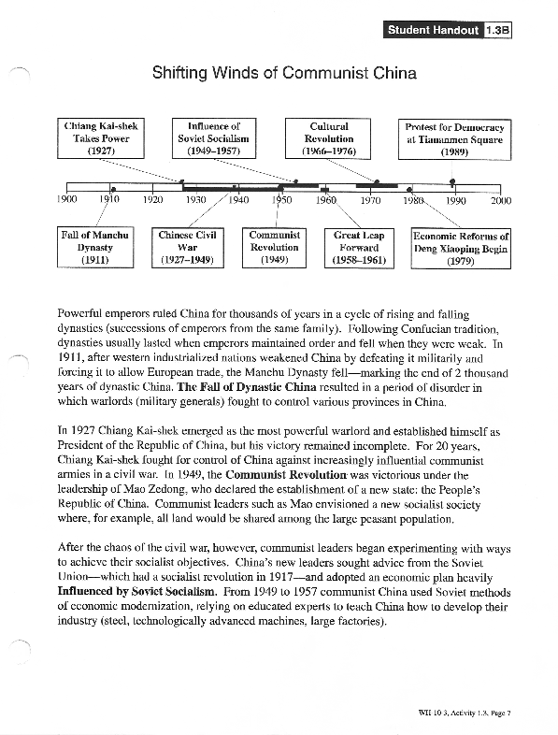

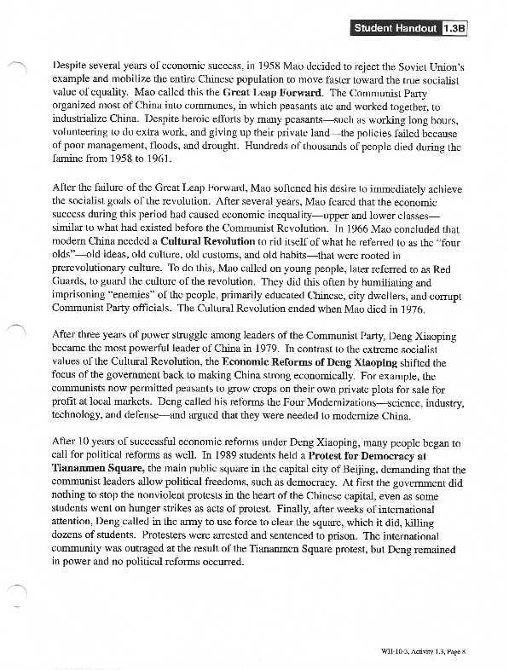

**Activity #2 -** Groups of students should be assigned to keep track of the actions of the following characters, or the appearance of the following themes:

1. Fugui seems to portray the corruption of Chinese society before the Communist takeover in 1949. What events transform him?

2. Jiazhen betrays common stereotypes of Chinese women as weak and submissive. Note the ways that she takes charge of her own and her children's lives. In what ways does she convey conventional wifely loyalty?

3. Fengxia is a daughter of the new China. What does it mean for the daughter of the new China to be silent or silenced? Why is she the one who cannot speak?

4. Yongqing is the son of Fugui and Jaizhen. Sons have long been preferred in Chinese society. He is pampered, yet nevertheless, he dies young. It is an old friend, who is now a communist party leader, who has accidentally killed the boy. What might the significance of that death?

5. Wan Er'xi is the husband of Fengxia. Why is he considered a suitable husband for Fengxia?

6. Long'er represents the old culture. He has won the house from Fugui. What happens to him and what might it mean?

7. The shadow puppet show is a recurring motif in the film. Keep track of the times the shadow puppets appear or are referred to in the film.

8. Social structures: Make note of the types of community interaction and traditions in the film. Observe the roles of grandparents, parents, and children.

9. Make note of the number of different campaigns of conflicts in the film. (Examples: Civil War, land reform, landlord and counterrevolutionary, Great Leap Forward, Great Proletarian Cultural Revolution (1966-1976), barefoot doctors)