Common Core Lesson Plan
Economics/Government
“Current Events”

Created by: Tara Howlett
Liberty High School
Kern High School District

Subject: Economics/Government

Unit Length: 2 periods

Content: Current Events

Common Core State Standards
Reading 8- Delineate and evaluate the argument and specific claims in a text, including the validity of the reasoning as well as the relevance and sufficiency of the evidence.
Writing 2- Write informative/explanatory texts to examine and convey complex ideas information clearly and accurately through the effective selection, organization, and analysis of content.

Day One
- Teacher passes out directions on current events (economics directions attached, government is easily modified).
- Students will discuss the importance of “current events” in economics and government, share out in groups.
- Teacher asks what importance other nation’s economies and governments have on the United States.
- Students will read the article “China Economy Sputters into Second Half of Year” independently.
- Students will then annotate the article in groups of two.
- Students will then follow the guidelines on the directions guided by teacher.

Day Two
- Students find article of relevance to apply to their own current event.

Writing Prompt

- Write a summary of the article in your own words. Include the main issues and its relevance to economics.
- State your opinion. Take a stand- say what you think will be the outcome good or bad and if you agree or not.
- Write 5 critical thinking/discussion questions. These will be the questions you will ask the class at the end of your presentation.

China Economy Sputters Into Second Half of Year

July trade and factory-price data disenchant, but analysts see signs of hope for economy
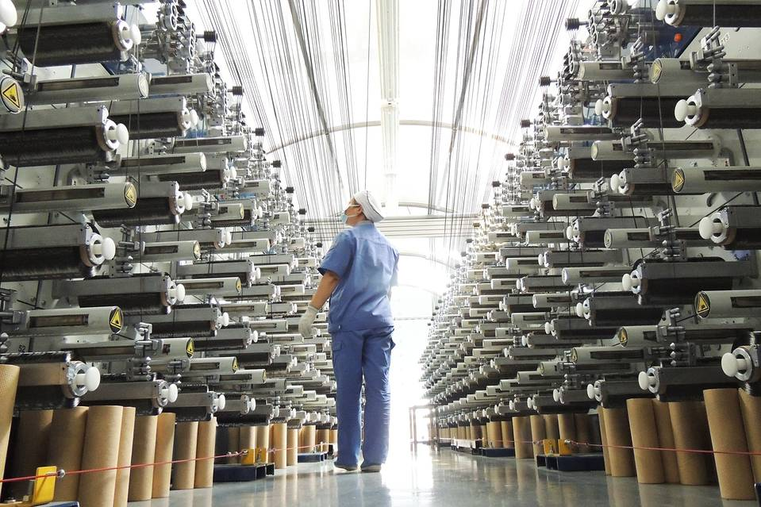
A worker at a carbon-fiber factory in Lianyungang, in China’s Jiangsu Province, on Aug. 1, 2015. The release of July’s trade and factory-price data suggests the nation’s economy is off to a slow start for the second half of the year Photo: Zuma Press
By
William Kazer
BEIJING—China’s economy started the second half of the year on a weak note, posting disappointing trade and factory-price data in July amid slack demand at home and abroad.
The government announced on Sunday that factory prices in July extended more than three years of declines, with the producer-price index taking its biggest year-over-year tumble in nearly six years.
Exports in July slid 8.3% from a year earlier, reversing a gain of 2.8% in June, customs data released Saturday showed. Imports fell for the ninth month in a row, dropping 8.1%, after a decline of 6.1% in June.
While there were bright spots in the trade picture, as imports of some key commodities made gains in volume terms, the figures were generally worse than expected and pointed to problems ahead on the already struggling export side.
“We could see relatively strong downward pressure on exports in the third quarter,” China’s General Administration of Customs said.
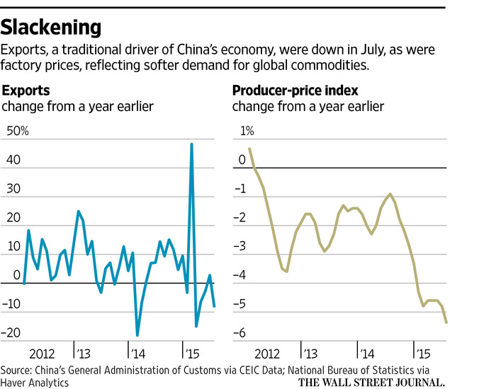
The nation’s export sector had been a major contributor to growth in past years. That is no longer the case, hampering economic growth.
China’s economic growth in the second quarter came in at 7% year-over-year—better than expected but well below the levels of recent years.
The government hopes to attain 7% growth for the full year, but that would still be the worst performance in more than two decades, amid a combination of overcapacity in traditional industries, a weak property sector and little help from exports.
China’s top government body, the State Council, said in July that it would give high priority to the nation’s trade sector, providing tax breaks and cutting red tape while reducing import duties. The government has accelerated a wide range of infrastructure projects to boost demand at home. The central bank has also cut interest rates four times since November in an effort to help struggling domestic companies obtain cheaper credit.
Exports for the first seven months of the year were down 0.8% in dollar terms compared with a year earlier, while imports were down 14.6% over the same period.
“There is no quick turnaround in sight,” said Liu Yaxin, an analyst at China Merchants Securities. She said exports will be hurt by sluggish demand as well as comparisons with relatively strong totals for the year-earlier period in the months ahead.
Adding to the problems of exporters is the relatively strong Chinese currency, which has held steady against a buoyant dollar. That has carried the yuan more than 10% higher against the euro.
“The strength of the yuan has been a drag on stable export growth in the European market,” said Chen Jie, general manager of Weida International Shoe Trade Company based in Wenzhou, in eastern China.
“We will look to expand our domestic business if things don’t get better soon, but that won’t be easy either,” he said.
Exports to the European Union fell 12% in July from a year earlier, while those to Japan dropped 13%, and exports to the U.S. were down 1.35%.
‘I think the government will be more proactive in its fiscal spending in the months ahead’
—Yang Zhao, economist at Nomura
For now, China’s central bank is showing no sign of easing its grip on the currency and letting the yuan depreciate—despite pressure from exporters for help.
“Pressure is intensifying on the central bank to let the currency depreciate, but I don’t think they will give in to the pressure,” said Singapore-based ING economist Tim Condon.
The combination of weak exports and even weaker imports left the nation with a trade surplus of $43 billion in July, down from $47 billion in June.
Weak imports have also reflected a steep decline in prices for key raw materials on global markets, in addition to the soft demand in China. But in volume terms, there were encouraging signs for import demand ahead, as imports of copper and iron ore were up in the month and imports of soybeans and crude oil jumped sharply.
Weak global commodities prices played a role in sending China’s factory prices lower in July. The producer-price index dropped 5.4% in July from a year earlier, accelerating its decline from a 4.8% year-over-year drop in June, and exceeding market forecasts. Meanwhile, consumer inflation turned higher in July, picking up pace to 1.6% year-over-year from 1.4% in June, though that was still well below the government’s ceiling of 3% for the year.
Analysts said that they saw more signs of hope for the economy as Beijing accelerates infrastructure projects to keep growth near the government’s 7% target for the full year.
“The government is now pushing infrastructure spending,” said Yang Zhao, economist at Nomura. “I think the government will be more proactive in its fiscal spending in the months ahead,” he said.
—Grace Zhu, Rose Yu and Lilian Lin contributed to this article.
Write to William Kazer at william.kazer@wsj.com

Honors Economics

Choose a Current Event: As a group pick 1 current event that relates to Economics. It can cover microeconomics (particular markets, consumer behavior, individual labor markets) or macroeconomics (monetary policy, inflation, unemployment, globalization). It can be an article that relates to the local, state, national, or global economy. Choose an article that is interesting and has enough information. Below is a list of good websites to look at.

New York Times www.nytimes.com
Time Magazine www.time.com
U.S. News and World Reports www.usnews.com
Newsweek www.newsweek.com
USA TODAY www.usatoday.com
Washington Post www.washingtonpost.com
Washington Times www.washtimes.com
CNN News www.cnn.com

Summarize the article: Print-out the article and attach it to your summary. You will be given ½ credit without the article.

- Write a summary of the article in your own words. Include the main issues and its relevance to economics.
- State your opinion. Take a stand- say what you think will be the outcome good or bad and if you agree or not.
- Write 5 critical thinking/discussion questions. These will be the questions you will ask the class at the end of your presentation.

Presentation: As a group you will present-not read your article to the class. Then you will ask your questions and call on students to answer them.

The current event is worth 50 points.
Name(s): ______________________ ____________________________
Presentation Date: ___________________________________

