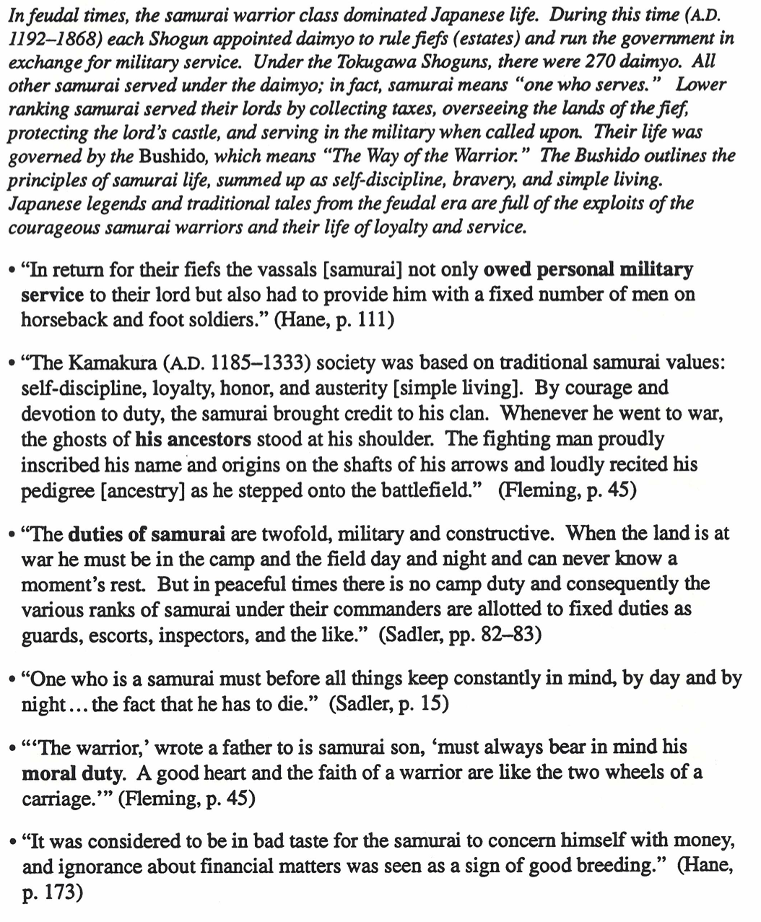

THE SAMURAI – JAPAN’S FEUDAL WARRIOR