**Name:** Maria Hernandez

**Course:** World History, Culture, and Geography: The Modern World **Grade:** 10th

**Time:** 90 minutes

**Standard(s):** 10.4: Students analyze patterns of global change in the era of New Imperialism in at least two of the following regions or countries: Africa, Southeast Asia, China, India, Latin American and the Philippines

**Objective (s):**

* Students will identify the causes and effects of the Opium War between Britain and China.

**Assessments (formal and/or informal)**

* Random calling—popsicle sticks
* Paragraph discussing causes and effects of Opium War

**Materials/Resources**

* Popsicle sticks with students’ names
* Causes and effects graphic organizer
* Computers with Internet access
* Opium War film clip

|  |  |  |  |
| --- | --- | --- | --- |
| **Activity** | **Time** |  | **Check**  **for Understanding** |
| **Review Objective** | 1 minute | * Teacher reviews objective of the day with students |  |
| **Activate Prior Knowledge** | 9  minutes | * Students answer Entrance Slip question.   **What does the American government do to control illegal drugs?** | Teacher calls on students randomly to share their responses |
| **Teacher Modeling** | 10 minutes | * Teacher explains to students that in the 19th century, the Chinese government had difficulty controlling the sale and consumption of opium. In their attempt to resolve the issue, the Chinese went to war with a very powerful and rich country, Great Britain. * Teacher explains that students will be visiting a website to learn about the issue. As they read the information on the website, they will complete a cause and effect graphic organizer.   <http://library.thinkquest.org/07aug/01291/Ritvik.html>   * Teacher reviews the structure of the cause and effect graphic organizer. The middle contains the main event (which in this case is the Opium War); on the boxes located on the left, students will include the significant events that caused the Opium War; on the right, they will include the significant events that occurred as a result of the war (consequences). |  |
| **Independent Practice** | 15 minutes | * Students read information on the website and complete graphic organizer | Teacher circulates the class to ensure that students are on task |
| **Closure** | 20  minutes | * Teacher instructs students to share their responses with elbow partners. * Teacher shows students a short video clip to reaffirm what they learned about the Opium War.   [**http://www.history.com/shows/mankind-the-story-of-all-of-us/videos/opium-in-china#opium-in-china**](http://www.history.com/shows/mankind-the-story-of-all-of-us/videos/opium-in-china#opium-in-china) | Teacher calls on students randomly to share their responses |
| **Independent Work** | 15 minutes | * Teacher instructs students to write a one-page response discussing the causes and effects of the Opium War.   **Write a paragraph discussing the causes and effects of the Opium War.** | Teacher randomly calls on students to read their paragraphs aloud. |
| **Extended Activity** |  | **Homework**  Search for a newspaper article that deals with the issue of drug control in the United States. Answer the following questions:   * **Where** are the illegal drugs coming from? * **How** are these drugs being brought into the country? * **Who** is consuming them? * **How** is the United States handling the problem?   Bring a hard copy of the article to class. |  |

**Name_________________________________ Date________________________Period_____________**

**Effects**

**Causes**

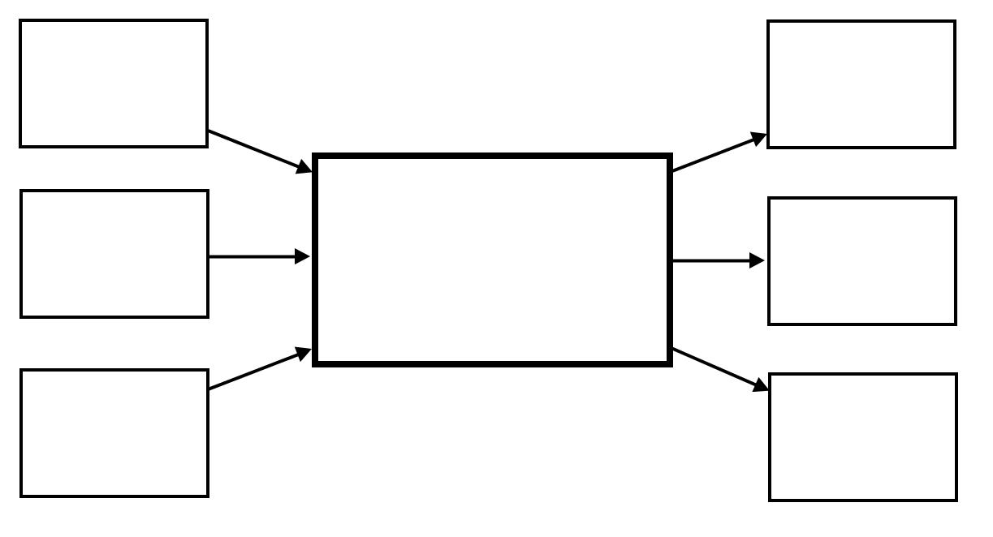

**Name:** Maria Hernandez

**Course:** World History, Culture, and Geography: The Modern World **Grade:** 10th

**Time:** 90 minute

**Standard(s):**

* 10.4: Students analyze patterns of global change in the era of New Imperialism in at least two of the following regions or countries: Africa, Southeast Asia, China, India, Latin American and the Philippines

**Objective (s):**

* Students will analyze the “Treaty of Nanking”

**Assessments (formal and/or informal)**

* Random calling—popsicle sticks
* Earn Your Seat activity
* One-page response stating whether they believe the “Treaty of Nanking” marked the beginning of the century of humiliation for the Chinese.

**Materials/Resources**

* Copies of “Treaty of Nanjing (Nanking), 1842”
* Popsicle sticks with students’ names
* “Treat of Nanking” graphic organizer

|  |  |  |  |
| --- | --- | --- | --- |
| **Activity** | **Time** |  | **Checking for Understanding** |
| **Review**  **Objective** | 1 minute | * Teacher reviews objective of the day with students |  |
| **Activate Prior Knowledge** | 9 minutes | * Earn Your Seat activity:   **What did you learn about the Opium War in the previous day’s lesson?** | Teacher uses popsicle sticks to randomly call on students to answer the question. If student gives an accurate answer he/she is allowed to sit down, otherwise, he/she must remain standing. |
| **Teacher**  **Modeling** | 15 minutes | * The teacher informs students that for the next activity they will be working in groups of three. She explains that they will be reading the “Treaty of Nanking” together as a group, discussing the main points in each section, and completing a graphic organizer. * Once students get into their assigned groups, the teacher distributes the “Treaty of Nanking” and instructs students to preview the text.   -**What** is the title of the text?  -**When** was it written?  -**Who** wrote it?  -**Who** signed it?   * Teacher calls on students randomly to answer these questions. * Once the teacher reviews the preview questions, she gives student directions for the reading activity.   **DIRECTIONS: Each student will take a turn reading aloud a section of the document. After the student finishes reading his section, the group will discuss the main points of the section, then they will write down their answers on the graphic organizer provided. They will repeat this process until they finish reading the entire text.** |  |
| **Guided**  **Practice** | 5 minutes | * Students read “Treaty” section, they discuss it in their groups, and write their responses on the graphic organizers provided | Teacher calls randomly on groups to share their responses. Teacher makes clarifications, if needed. |
| **Independent Practice** | 25 minutes | * Students read “Treaty of Nanking” in their respective groups, and complete graphic organizer. | Teacher listens closely to each group to ensure all students are on task. |
| **Closure** | 15 minutes | * Teacher writes the following question on the board and asks students to answer the question citing examples from the text to support their answers.   ***Many Chinese consider the signing of the Treaty of Nanking the beginning of the century of humiliation. What evidence of this claim is there in this primary source document?***   * The teacher asks students to share their responses with their group members. | Teacher calls randomly on students to share their answers with the entire class. Teacher writes students’ responses on the board. |
| **Independent**  **Work** | 20 minutes | * Teacher instructs students to write a one-page response to the following prompt   ***Many Chinese consider the signing of the Treaty of Nanking the beginning of the century of humiliation. What evidence of this claim is there in this primary source document?*** |  |

**Treaty of Nanking**

|  |  |
| --- | --- |
|  | **Main Points** |
| TREATY |  |
| Article 1 |  |
| Article II |  |
| Article III |  |
| Article IV |  |
| Article VI |  |
| Article VII |  |
| Article VIII |  |
| Article IX |  |
| Article V |  |
| Article VI |  |
| Article VII |  |
| Article VIII |  |