Lisa Quon: Multi-Lesson Curriculum Project: USC East Asian Since 1900

This monthly unit is a part of a series of units that celebrates the theme of Diversity for kindergarten students, and coincides with the month in which certain holiday events occur. For instance, this Asian unit will be taught in February, when the Lunar New Year occurs. Students will understand that history relates to events, people, and places of other times. History/Social Studies Standard K.6.3, ELA Standards RI.K.1-3, 9-10; SL.K. 2,3,6; W.K. 5-6, 8

LESSON 1

Rationale: Students will learn about the Chinese New Year through text sets, close reading, and charting ideas.  Time: 6-7 days, approximately 20 minutes per day.  Instruction: Whole Group | History/Social Studies Standard: K.6.3  ELA Standards: RI.K.1-3,9-10; SL,K.2, 3, 6.
The first two books are intentionally selected for the first two reads because they can be read quickly. The last book Lion Dancer is longer and may take two days to close read and chart. The third book may be optional, or Teacher may select two out of the three books to match appropriateness to student needs.  Day 1: Teacher reads My First Chinese New Year.  Day 2: Prepare a circle map with the words “Chinese New Year activities” in the center.  Teacher is close reading with students. She tells students she will reread the book, but she will stop and have students pair share about activities that occur during Chinese New Year based on the book. Then students share out only ideas that come from the book. Teacher immediately charts student ideas with simple words and basic illustrations. Teacher reviews the chart of student information.  Day 3: Teacher reads Bringing in the New Year. Then teacher reviews chart.  Day 4: Teacher reviews chart. Teacher is close reading with students. She rereads the book, and has students pair share about activities that occur during Chinese New Year based on the book. Students share out ideas from the book. Teacher charts only NEW ideas that have not already been charted. Teacher talks through the charting process by asking the students, “Do we already have this activity/idea up on our chart? If not, then we can add it on. But if we do have the information already, we don’t need to write it again.”  Day 5: Read Lion Dancer: Ernie Wan’s Chinese New Year. Teacher reviews chart  Day 6 – 7: Teacher reviews chart. Teacher does a close reading of the book and charts any new information. | Materials: My First Chinese New Year by Karen Katz  Bringing in the New Year by Grace Lin  Lion Dancer: Ernie Wan’s Chinese New Year by Kate Waters  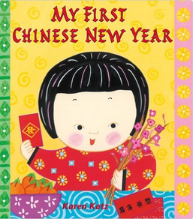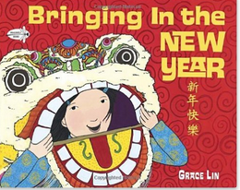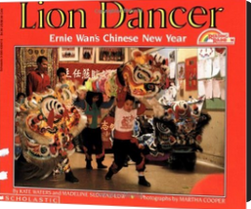  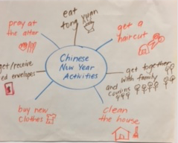
Assessment: Teacher observes and listens intently to student responses with each other when Teacher is asking questions about the book.

LESSON 2

Rationale: Students will demonstrate knowledge of Chinese New Year activities through informative writing pieces.  Time: 3-5 consecutive days, approximately 20 minutes per day. Must be done in small groups.  Instruction: Small group up to 6 students | History/Social Studies Standard K.6.3  ELA Standards: W.K.2, 5-6, 8
In this writing process, it is very methodical and somewhat tedious but because it is consistent, students know the information well. Over time, you will see students writing more than one sentence a day. Additionally, they are going through all the steps of the writing process daily. Students are experiencing all steps of language: reading, writing, listening, and speaking.  Day 1: Teacher reviews chart from Lesson 1. Teacher writes topic sentence: “Chinese people do many activities in the new year.” and orally rehearses it with students as they tap out each word on their fingers. Teacher models “tapping.” This physical and oral technique is used to isolate each word so students can space each word when writing. Depending upon experience with writing, Teacher may model where to write the topic sentence, or students may not need modeling. Only the topic sentence is written on Day 1. Students reread what they have written aloud to (1) him/her self, (2) writing partner, (3) and Teacher. The idea of this last step of writing, reading aloud, is to correct errors.  Day 2: Students reread aloud writing from previous day. Read to him/her self, partner, and if time permits, Teacher. Teacher reviews chart. Using the chart if needed, students will orally dictate 1 activity that takes place during Chinese New year. They say and tap to him/her self, then to partner, and finally to Teacher. Teacher makes corrections as needed. Student then writes the statement, which follows the topic sentence. Student rereads the sentence written today and makes necessary corrections. Then student rereads the entire paper (of just 2 sentences).  Day 3: Repeats Day 2, but writes another sentence describing another activity.  Day 4: Repeats Day 2.  Day 5: Repeats Day 1, but teacher helps with closing sentence. “Chinese New Year is fun!” or “Chinese New Year is busy!” Student again rereads and corrects writing piece.  Student may illustrate the writing piece upon completion of writing. | Materials: student writing paper, pencil, crayons, chart created from Lesson 1
Assessment: Student writing samples demonstrate content knowledge and writing skills. Teacher can also have students read aloud completed writing during presentations.

LESSON 3

Rationale: Students will demonstrate knowledge of Chinese New Year activities through a self-written book using technology. If technology is unavailable, students can make books using information from chart in Lesson 1.  Time: 3-5 consecutive days, approximately 20 minutes per day.  Instruction: Small group up to 6 students | History/Social Studies Standard K.6.3  ELA Standards: W.K2, 5-6, 8
Like the writing piece in Lesson 3, this is tedious and will be a long process initially, but the more technology usage and book writing, the more proficient students become making these books on the ipad. Students can also record their voice reading each sentence. This lesson meets the Language Arts skills of reading, writing, listening, and speaking.  Day 1: Students reread writing piece from Lesson 2. Teacher models how to input information with photo on each page of book. All information is extracted from writing completed in Lesson 2, or if students did not do Lesson 2, information can be obtained from chart completed with the teacher in Lesson 1.  Day 2-5: See Day 1. Amount of time needed is dependent upon student ipad proficiency. | Materials: I pad, Story Creator app  
Assessment: Student writing samples demonstrate content knowledge and writing skills, and possible technology skills if using ipad or other tool.

