**Lesson Plans Day 1**

A Scholar prepares for his Art Studies: Setting the Scene for the 7th grade art students Calligraphy

Students will enter the studio to the sound of quiet, gentle music and experience the scent of jasmine blooms. Table groups will take their assigned seats, and notice a curious box and a teapot at the center of each of their tables.

With a barely audible voice the instructor will guide them into focusing on remaining quiet while the (#1) designated student at each table will pass out the paper cups and pour a small taste of cooled flavored tea. Students will taste one sip of tea without making comments and if the taste is favorable students will finish their cup.

Hopefully these 7th grade students have had their senses awakened through unusual sounds, sights, smells and tastes and are now ready to transform into art scholars for the day (art elective period).

The (#2) designated student at each table will carefully remove the teapot and paper cups to the studio sink area. The lucky (#3) designated student will open the mysterious scholar box and find four calligraphy brushes and four sheets of rice paper, this student will *caution the table group* to be extremely gentle with these scholarly tools while handing them out to each art student.

Instructor will ask each student to observe their “scholar tools” carefully and gently and after students have had time to observe the Asian style calligraphy brush and the Asian style rice paper, instructor will guide students into a compare and contrast discussion about the paper and brush. (The art students having had experience with paint brushes before should notice the very sharp tipped brush and the delicateness of the rice paper.)

Designated (#4) student will return the brushes and paper to the box and carry the box to the sink area of the studio.

Day 1 will culminate with art history slides showing traditional calligraphy brushes, scholar table-benches, and three scholar portraits from China, Japan and Korea.

Students may ask questions about the slides and about Day 2 activities to come.

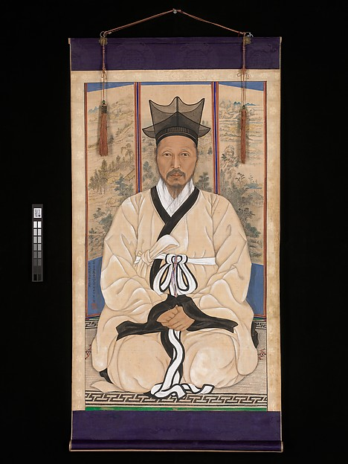

Portrait of a Scholar 1921

Korean

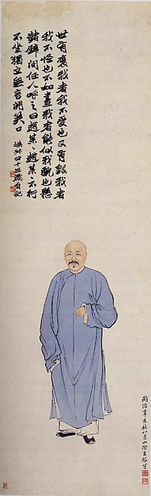

Qing Dynasty Scholar

1644-1911

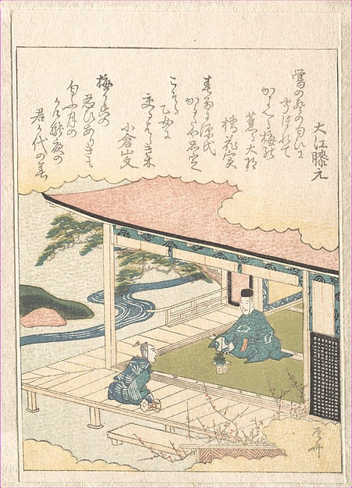

Edo period Samurai (Scholar)

Contemplating the Plum Blossom Gift

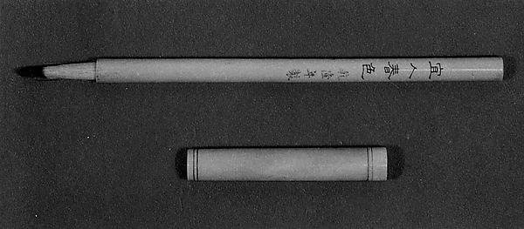

Chinese Calligraphy Brush (Ivory) 1700’s

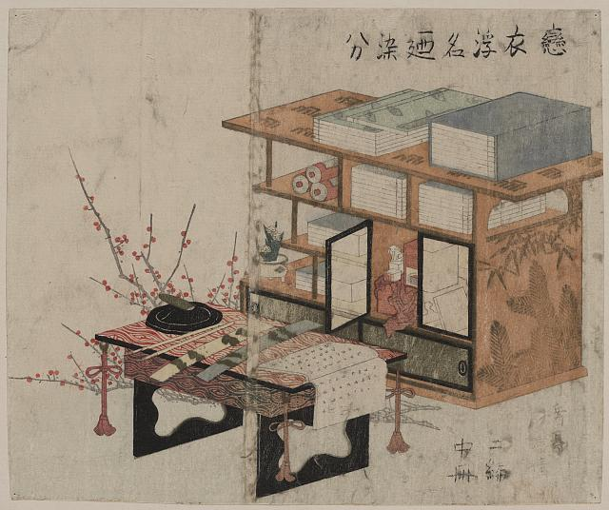

Chinese Scholar’s Desk