**Lesson Plan Template**

|  |
| --- |
| **Course:** World History |
| **Number of days:**  4 |
| **Class Period(s):** Three 50 minutes + 30 minute period |

|  |
| --- |
| **Essential Question/Theme** |
| What open-ended philosophical, moral, and intellectual question will guide students’ inquiry into this topic?   * *How is history censored?* * *What are the benefits and the costs of censorship?* |
| **Content Standards/Learning Objectives** |
| * CA Standard 10.9.4.: Analyze the Chinese Civil War, the rise of Mao Tse-tung, and the subsequent political and economic upheavals in China (e.g., the Great Leap Forward, the Cultural Revolution, and the Tiananmen Square uprising). * Objective: Students will analyze the Tiananmen Square Incident using a documentary and excerpts from the book *The People’s Republic of Amnesia: Tiananmen* Revisited to understand the events that occurred. Then students will create a piece using the perspective of sources and ultimately write a letter to the Chinese government supporting or denouncing their decision to censor the Tiananmen Square Incident. |
| **Be Able To Do – Skills** |
| What intellectual/academic skills or processes will students be taught, introduced to, or expanded upon?   * Students will review main points from previous lessons on types of governments * Students will do a critical analysis of the Tiananmen Square incident to examine the effects of censorship * Students will analyze various sources and collect evidence in preparation for their written assignment in which they answer the question: Should China have censored the Tiananmen Square Incident? * Students will take a stance on China’s actions in response to the Tiananmen Square Incident |
| **Assets** |
| How will you access students’ prior knowledge/assets?   * Students will start the class with a “Do Now.” This will activate their thinking in preparation for the anticipatory set in which they analyze a documentary. * Students will also choose from either an X-ray profile or a Say, Mean, Matter for one of their assessments, both of which students are familiar with from previous lessons. |
| **Assessment** |
| In what multiple ways will you be assessing student learning of both the content and the academic/intellectual skill set you are teaching them? What will the final assessment be? How will you teach to it?   * Mini-discussions throughout the video will be used as an informal assessment of students understanding of the events during the Tiananmen Square Incident. * Students will create a X-ray profile or a monologue (whichever they feel is most appropriate to show their understanding) based on the information gathered through the excerpts in order to demonstrate their examination of the event’s impact on human lives. * Students will be formally assessed on their written response on their opinion on the ethics of the censorship of the Tiananmen Square Incident in China. They will use evidence to support their opinion on whether they believe China’s censorship practices are ethical. |

**Teacher Daily Lesson Plan Template**

**Day 1**

|  |  |  |
| --- | --- | --- |
| **Entry Point** - How will you introduce students to the inquiry? | | |
| **Time** | **Description of Activity** | **Materials** |
| 10 minutes | * Do Now * Students will write a brief paragraph on the following: *True or False: Censorship is beneficial. Explain your answer.* | * PowerPoint slide * Projector |
| **Transition**  How will you transition students from the first activity to the next? How will they connect?  Students will share their responses to the Do Now prompt. They will be informed that the lesson for the day will involve analyzing the Tiananmen Square Incident and whether censorship was beneficial or hurtful for the people of China.  Possible discussion questions/sentence starters:   * Describe why you think censorship is beneficial or not. * What is usually censored? * Why do you think censorship exists? * What is the significance of censorship? | | |
| **Activity 1** | | |
| **Time** | **Description of Activity** | **Materials** |
| 1. minutes | * Discuss the word censorship; Have students share out what they know, make a list of things that are “censored” and why they are censored. Then create general themes of censored items. * Anticipatory Set: Students will learn a brief history about the purpose of reporters in China before the Tiananmen Square Incident | * None |
| **Transition**  How will you transition students from the previous activity to the next? How will they connect?  I will explain that today’s lesson will explore the censorship in historical storytelling. | | |
| **Activity 2** | | |
| **Time** | **Description of Activity** | **Materials** |
| 35 minutes | * Students will view the documentary *Assignment China: Tiananmen Square*. They will jot down their ideas on their notions of the event. The video will be paused every 10-20 minutes as needed. A brief share out will be facilitated for students to share their thoughts. \*\*\**Refer to the essential question to help guide the discussion.* | * Projector * Video: *Assignment China: Tiananmen Square* |
| **Transition**  How will you transition students from the previous activity to the next? How will they connect?  Students will share their thoughts on the video. The discussion will be centered around the question: *How is history censored?* | | |

**Day 2**

|  |  |  |
| --- | --- | --- |
| **Entry Point - How will you introduce students to the inquiry?** | | |
| **Time** | **Description of Activity** | **Materials** |
| 5 minutes | * Review video; ask students to recall prior knowledge | * Video |
| **Transition**  How will you transition students from the first activity to the next? How will they connect?  Students will share information regarding the documentary from the day before. They will be reminded that the lesson for the day will involve analyzing the Tiananmen Square Incident and whether censorship was beneficial or hurtful for the people of China. | | |
| **Activity 1** | | |
| **Time** | **Description of Activity** | **Materials** |
| 45 minutes | * Students will view the documentary *Assignment China: Tiananmen Square*. They will jot down their ideas on their notions of the event. The video will be paused every 10-20 minutes as needed. A brief share out will be facilitated for students to share their thoughts. \*\*\**Refer to the essential question to help guide the discussion.* | * Projector * Video: *Assignment China: Tiananmen Square* |
| **Transition**  How will you transition students from the previous activity to the next? How will they connect?  Students will share their thoughts on the video. The discussion will be centered around the question: *How is history censored?* Go back to the list they made of “censored” themes for things that are censored. Do the elements of the Tiananmen Square Incident fit into these themes*?* | | |

**Day 3**

|  |  |  |  |  |
| --- | --- | --- | --- | --- |
| **Entry Point - How will you introduce students to the inquiry?** | | | | |
| **Time** | **Description of Activity** | | **Materials** | |
| 5 minutes | * Review video; ask students to recall prior knowledge | | * Video | |
| **Transition**  How will you transition students from the first activity to the next? How will they connect?  Students will share information regarding the documentary from the day before. They will be reminded that the lesson for the day will involve analyzing the Tiananmen Square Incident and whether censorship was beneficial or hurtful for the people of China. | | | | |
| **Activity 1** | | | | |
| **Time** | **Description of Activity** | | **Materials** | |
| 40 minutes | * Note taking * Students will read an excerpts and collect information on the individuals life * Students will create either an X-ray profile (drawing of the person with comments on each body part) relating to the information collected or will fill out the Say, Mean, Matter page based on information collected from the reading | | * Excerpts from *The People’s Republic of Amnesia: Tiananmen Revisited* | |
| Transition  How will you transition students from the previous activity to the next? How will they connect?  I will explain to students that we will examine and compare the experiences of people during this incident via sharing the quotes or X-ray profiles. Students will jot down notes on commonalities and differences between the experiences. | | | | |
| **Activity 2** | | | | |
| **Time** | | **Description of Activity** | | **Materials** |
| 5 minutes | | * Students will complete an exit slip on the following: *Why do you think these stories were censored until Louisa Lim wrote the book? Do you believe that other people benefit or are hurt by knowing these stories?* | | * Paper * PowerPoint |
| Transition  How will you transition students from the previous activity to the next? How will they connect?  I will share out some of the responses that students had from the exit slips using the elmo projector. I will refer back to the discussion we had on censorship and ask students to recall their responses on whether censorship is beneficial. Then I will explain to students that the goal of today’s lesson is to formulate an opinion on China’s censorship. | | | | |

**Day 4 (30 minute period)**

|  |  |  |
| --- | --- | --- |
| **Activity 1** | | |
| **Time** | **Description of Activity** | **Materials** |
| 30 minutes | * Students craft an evidence based written response on the events of Tiananmen Square by writing a letter to the government of China answering the following question: Should China have censored the Tiananmen Square Incident? (Consider the costs and benefits of censorship in your response). | * Written response criteria for success * Sentence Starters * Rubric |
| **Summary** | | |
| How will you sum up or end the day? How will you ensure that students see the connection between the day’s activities? What will you leave students with to continue their learning, their understanding?  Students will share their thoughts on the Tiananmen Square Incident and its censorship. Students will also share out how these lessons will influence their understanding of history and the media. | | |

X-Ray

Directions: Use the accounts from the book to fill in the boxes below.

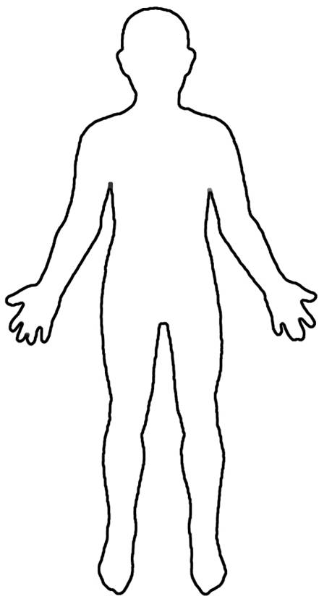

Mouth: What he/she said  
_________________________________________________________________________________________________________________________________________________________________________________________________________________________________________________________________________________________________________________________________________

Age:______________

Basic information about this person:

http://bestclipartblog.com/clipart-pics/lips-clip-art-4.png

Hands- what he/she touched.

____________________________________________________________________________________________________________________________________________________________________________________________________________________________________________________________________________________________________________________________________________________________________________________________________________________________________________________________________________________________________________________________________________________________________________________________

Heart: What he/she feels

_________________________________________________________________________________________________________________________________________________________________________________________________________________________________________________________________________________________________________________________________________________________________________________________________________________________________________________________________________________________________________________________________________________________________

Legs: Where he/she went __________________________________________________________________________________________________________________________________________________________________________________________________________________________________________________________________________________________________________________________________________________________________________________________________________________

Name:________________________________ Per._____

Say, Mean, Matter

Directions: Find 3 quotes in the documents and fill out the sheet below.

|  |  |  |
| --- | --- | --- |
| **Say/See**  **(Provide one quote with the author)** | **Mean**  **(What does the quote mean?)** | **Matter**  **(Why is this quote important? What does it tell us about the time period?)** |
|  |  |  |
|  |  |  |
|  |  |  |