Lesson Two

Grade: 4

BACKGROUND

Visualization is an important reading strategy taught in the elementary grades. And having students be able to express visually, as well as orally, and in writing, what they read is equally important. At any point in the school year, the teacher will be able to use this lesson. It ties in with myths, fables, tall tales, fiction, or cultural studies. Gifted students will find that the Icons for Depth & Complexity are in play here especially Multiple Perspective, and Ethics. English Language Learners will find this activity challenging and engaging. They will be able to understand the text and be able to use visuals to share out.

OVERVIEW
Students will read grade appropriate text, discuss, write a reflection, and visually depict what they have read. Students may also wish to continue the story, or add to the narrative. The teacher may or may not have taught the skill of visually depicting a written story. This lesson can be the introduction for such a skill, or a culminating project after having successfully done these types of activities during the school year.

CONTENT STANDARDS

Art
From: http://www.cde.ca.gov/be/st/ss/vagrade4.asp

2.0 CREATIVE EXPRESSION
Creating, Performing, and Participating in the Visual Arts
Students apply artistic processes and skills, using a variety of media to communicate meaning and intent in original works of art.

4.0 AESTHETIC VALUING
Responding to, Analyzing, and Making Judgments About Works in the Visual Arts
Students analyze, assess, and derive meaning from works of art, including their own, according to the elements of art, the principles of design, and aesthetic qualities.

5.0 CONNECTIONS, RELATIONSHIPS, APPLICATIONS
Careers and Career-Related Skills
- 5.4 Read biographies and stories about artists and summarize the readings in short reports, telling how the artists mirrored or affected their time period or culture.
Writing
Text Types and Purposes
W.4.1: Write opinion pieces on topics, supporting a point of view with reasons and information.
W.4.1.b: Provide reasons that are supported by facts and details.
W.4.2.d: Use precise language and domain-specific vocabulary to inform about or explain the topic.
Production and Distribution of Writing
W.4.4: Produce clear and coherent writing in which the development and organization are appropriate to task, purpose, and audience.
Research to Build and Present Knowledge
W.4.7: Conduct short research projects that build knowledge through investigation of different aspects of a topic.
W.4.8: Recall relevant information from experiences. Take notes and categorize information.
Range of Writing
W.4.10: Write routinely over extended time frames and shorter time frames for a range of discipline-specific tasks, purposes, and audiences.

Speaking and Listening
Comprehension and Collaboration
SL.4.1.b: Follow agreed-upon rules for discussions and carry out assigned roles.
SL.4.1.c: Pose and respond to specific questions to clarify or follow up on information, and make comments that contribute to the discussion and link to the remarks of others.
SL.4.3: Identify the reasons and evidence a speaker provides to support particular points.
Presentation of Knowledge and Ideas
SL.4.4: Recount an experience in an organized manner, using appropriate facts and relevant, descriptive details; speak clearly at an understandable pace.
SL.4.5: Add audio recordings and visual displays to presentations.
SL.4.6: Differentiate between contexts that call for formal English and situations where informal discourse is appropriate, use formal English when appropriate to task and situation.

ELA-Literacy
Foundational Skills
Fluency
RF.4.4: Read with sufficient accuracy and fluency to support comprehension.
RF.4.4.a: Read grade-level text with purpose and understanding.
Informational Text
Key Ideas and Details
RI.4.1: Refer to details and examples in a text when explaining what the text says.
RI.4.3: Explain procedures, ideas, or concepts in a scientific, or technical text, based on specific information in the text.
Craft and Structure
RI.4.4: Determine the meaning of domain-specific words or phrases in a text relevant to grade 4.
Integration of Knowledge and Ideas
RI.4.7: Interpret information presented visually, orally, or quantitatively and explain how the information contributes to an understanding of the text in which it appears.

MATERIALS

• Text of Peach Blossom Spring (by Tao Qian)
• Asia Week Interactive Journal
• Art Supplies
• School Supplies
• (Google Images) Comic Strip template (see examples below)

OPENING

Teacher will use Brainpop to show the quick video and quiz on “Great Wall of China.”

DIRECT INSTRUCTION
Students will read the story “Peach Blossom,” either whole class, or independently as decided by the classroom teacher. Depending on the class, the teacher can stop at points along the story to discuss, and ask students to sketch a scene, or write notes about the plot, character, and setting. Once the story is read, the teacher will discuss the meaning. Here the teacher can chart out the ideas, or have students write and share out ideas. Teacher may select a portion of the story and show what he or she has drawn about the scene. For example, in the sentence “One day, as he followed the course of a stream…” the teacher can sketch (or have prepared) a drawing of what the stream would look in his or her mind. There are no real wrong or right answers. Students then will take a sentence given by the teacher to sketch.

INDEPENDENT PRACTICE
Students will take the work as a whole, or in part, to create a visual travelogue of the story. It is here that they will have options. Either by table groups, partners, or independently, students will recreate the written story as a comic strip, a travel brochure (templates from Pages on Mac, or Microsoft Office), a poster or flyer advertising the location of this Shangri-La, or a digital design.
EXTENSION
Students may use iMovie, Keynote, or Power Point, students can create a digital description of their work for presentations and upload the work to our class website, Edmodo, or Class Dojo. With iMovie specifically, they can create a movie trailer for Peach Blossom – where in a minute or less they create a written narration, and visuals to tell the story.

EXAMPLES

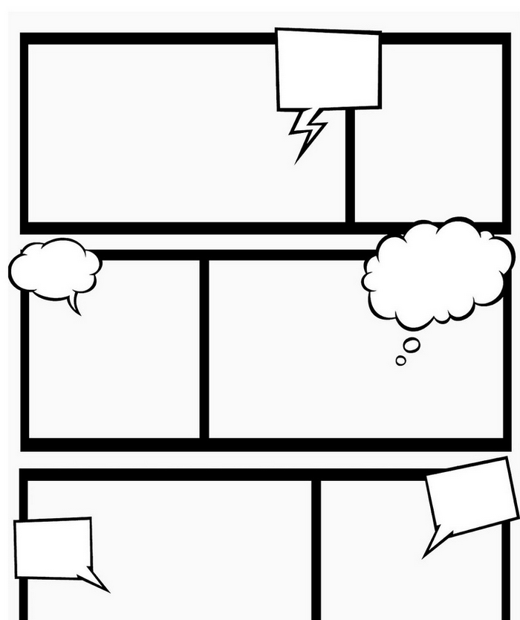

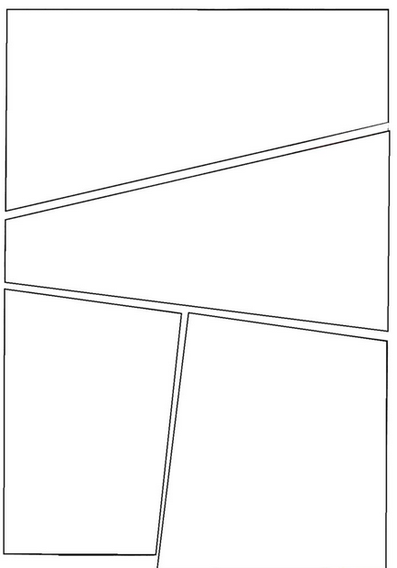

“Peach Blossom Spring”
By Tao Qian
During the reign period T’ai yuan [326-97] of the Chin dynasty there lived in Wu-ling a certain fisherman. One day, as he followed the course of a stream, he became unconscious of the distance he had travelled. All at once he came upon a grove of blossoming peach trees, which lined either bank for hundreds of paces. No tree of any other kind stood amongst them, but there were fragrant flowers, delicate and lovely to the eye, and the air was filled with drifting peach bloom.

The fisherman, marveling, passed on to discover where the grove would end. It ended at a spring; and then there came a hill. In the side of the hill was a small opening, which seemed to promise a gleam of light. The fisherman left his boat and entered the opening. It was almost too cramped at first to afford him passage; but when he had taken a few dozen steps he emerged into the open light of day. He faced a spread of level land. Imposing buildings stood among rich fields and pleasant ponds all set with mulberry and willow. Linking paths led everywhere, and the fowls and dogs of one farm could be heard from the next. People were coming and going and working in the fields. Both the men and the women dressed in exactly the same manner as people outside; white-haired elders and tufted children alike were cheerful and contented.

Some, noticing the fisherman, started in great surprise and asked him where he had come from. He told them his story. They then invited him to their home, where they set out wine and killed chickens for a feast. When news of his coming spread through the village everyone came in to question him. For their part they told how their forefathers, fleeing from the troubles of the age of Ch’in, had come with their wives and neighbors to this isolated place, never to leave it. From that time on they had been cut off from the outside world. They asked what age was this: they had never even heard of the Han, let alone its successors the Wei and the Chin. The fisherman answered each of their questions in full, and they sighed and wondered at what he had to tell. The rest all invited him to their homes in turn, and in each house food and wine were set before him. It was only after a stay of several days that he took his leave. “Do not speak of us to the people outside,” they said. But when he had regained his boat and was retracing his original route, he marked it at point after point; and on reaching the prefecture he sought audience of the prefect and told him of all these things. The prefect immediately dispatched officers to go back with the fisherman. He hunted for the marks he had made, but grew con fused and never found the way again.

The learned and virtuous hermit Liu Tzu-chi heard the story and went off elated to find the place. But he had no success, and died at length of a sickness. Since that time there have been no further “seekers of the ford.”

