Lesson One

Grade: 4

BACKGROUND
Living in the urban / suburban world that many of our students do here in the Los Angeles Unified School District, the use of nature to teach might sound impractical. Homes with small gardens, apartments with no green space, and add to that the California drought and it begins to look insurmountable to include nature with math.
In this lesson, done after a (potential) field trip to the gardens of either the Huntington Library or Japanese Friendship Garden in the San Fernando Valley, will be involved with creating a garden while using English Language Arts, Math, and Art.

OVERVIEW
Students will read excerpts from Qi Biaojia's Footnotes to Allegory Mountain. Analyze the text in group discussions, and sketch out what the garden looked like based on the text. Students will have had the opportunity to see first hand a Japanese or Chinese garden through the field trip or virtual field trip. They will sketch their own garden, create one with art supplies, and then write a description of the garden. Because of their field trip experience we will go over the importance of community gardens and how immigrants have brought their culture to our state and with that their unique styles of gardens.

CONTENT STANDARDS
Math
From: http://www.corestandards.org/Math/Content/4/G/
Draw and identify lines and angles, and classify shapes by properties of their lines and angles.
CCSS.Math.Content.4.G.A.1
Draw points, lines, line segments, rays, angles (right, acute, obtuse), and perpendicular and parallel lines. Identify these in two-dimensional figures.
CCSS.Math.Content.4.G.A.2
Classify two-dimensional figures based on the presence or absence of parallel or perpendicular lines, or the presence or absence of angles of a specified size. Recognize right triangles as a category, and identify right triangles.
CCSS.Math.Content.4.G.A.3
Recognize a line of symmetry for a two-dimensional figure as a line across the figure such that the figure can be folded along the line into matching parts. Identify line-symmetric figures and draw lines of symmetry.
Math Practices
MP.4 Model with mathematics.
MP.5 Use appropriate tools strategically.

Art
From: http://www.cde.ca.gov/be/st/ss/vagrade4.asp

2.0 CREATIVE EXPRESSION
Creating, Performing, and Participating in the Visual Arts
Students apply artistic processes and skills, using a variety of media to communicate meaning and intent in original works of art.

3.0 HISTORICAL AND CULTURAL CONTEXT
Understanding the Historical Contributions and Cultural Dimensions of the Visual Arts
Students analyze the role and development of the visual arts in past and present cultures throughout the world, noting human diversity as it relates to the visual arts and artists.
Diversity of the Visual Arts
- 3.2 Identify and discuss the content of works of art in the past and present, focusing on the different cultures that have contributed to California's history and art heritage.

4.0 AESTHETIC VALUING
Responding to, Analyzing, and Making Judgments About Works in the Visual Arts
Students analyze, assess, and derive meaning from works of art, including their own, according to the elements of art, the principles of design, and aesthetic qualities.

5.0 CONNECTIONS, RELATIONSHIPS, APPLICATIONS
Careers and Career-Related Skills
- 5.4 Read biographies and stories about artists and summarize the readings in short reports, telling how the artists mirrored or affected their time period or culture.
Writing
Text Types and Purposes
W.4.1: Write opinion pieces on topics, supporting a point of view with reasons and information.
W.4.1.b: Provide reasons that are supported by facts and details.
W.4.2.d: Use precise language and domain-specific vocabulary to inform about or explain the topic.
Production and Distribution of Writing
W.4.4: Produce clear and coherent writing in which the development and organization are appropriate to task, purpose, and audience.
Research to Build and Present Knowledge
W.4.7: Conduct short research projects that build knowledge through investigation of different aspects of a topic.
W.4.8: Recall relevant information from experiences. Take notes and categorize information.
Range of Writing
W.4.10: Write routinely over extended time frames and shorter time frames for a range of discipline-specific tasks, purposes, and audiences.

Speaking and Listening
Comprehension and Collaboration
SL.4.1.b: Follow agreed-upon rules for discussions and carry out assigned roles.
SL.4.1.c: Pose and respond to specific questions to clarify or follow up on information, and make comments that contribute to the discussion and link to the remarks of others.
SL.4.3: Identify the reasons and evidence a speaker provides to support particular points.
Presentation of Knowledge and Ideas
SL.4.4: Recount an experience in an organized manner, using appropriate facts and relevant, descriptive details; speak clearly at an understandable pace.
SL.4.5: Add audio recordings and visual displays to presentations.
SL.4.6: Differentiate between contexts that call for formal English and situations where informal discourse is appropriate, use formal English when appropriate to task and situation.

ELA-Literacy
Foundational Skills
Fluency
RF.4.4: Read with sufficient accuracy and fluency to support comprehension.
RF.4.4.a: Read grade-level text with purpose and understanding.
Informational Text
Key Ideas and Details
RI.4.1: Refer to details and examples in a text when explaining what the text says.
RI.4.3: Explain procedures, ideas, or concepts in a scientific, or technical text, based on specific information in the text.
Craft and Structure
RI.4.4: Determine the meaning of domain-specific words or phrases in a text relevant to grade 4.
Integration of Knowledge and Ideas
RI.4.7: Interpret information presented visually, orally, or quantitatively and explain how the information contributes to an understanding of the text in which it appears.
Social Studies
4.4 Students explain how California became an agricultural and industrial power, tracing the transformation of the California economy and its political and cultural development since the 1850s.
9. Analyze the impact of twentieth-century Californians on the nation's artistic and cultural development
MATERIALS

• http://www.thejapanesegarden.com/
• http://www.huntington.org/chinesegarden/
• http://www.huntington.org/JapaneseGarden/
• School cafeteria trays
• Art supplies (crayons, color pencils, markers, paints, pastels – depends on school availability)
• Pencil/paper
• (Excerpts from) Studies in the History of Gardens & Designed Landscapes: Qi Biaojia' s ‘Footnotes to Allegory Mountain’ (http://webcache.googleusercontent.com/search?q=cache:A6dHuoavdAwJ:https://newterrains.files.wordpress.com/2015/01/campbell-qibiaojia.pdf+&cd=3&hl=en&ct=clnk&gl=us)

OPENING
Teacher will use Brainpop Jr. to show the quick video and quiz on “Ancient China.”

DIRECT INSTRUCTION
In Student’s interactive journal, they will have taken some notes from their observations at the garden field trip: sketches of architecture, design / layout of plants, buildings, and overall map. They will have written about their feelings about being in the gardens, which was their favorite portion and why, and where they would bring their parents and what they would say to them about the section.

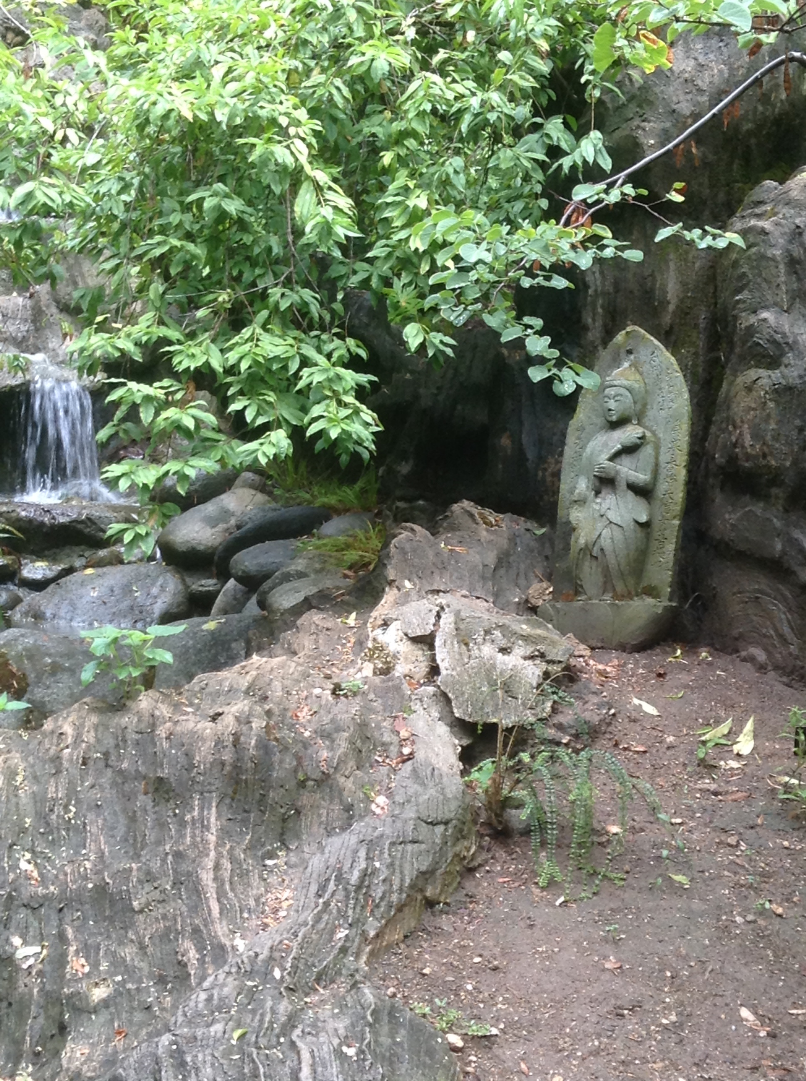
Example: In this picture from the Japanese garden at the Huntington, I would describe it as peaceful, with the quiet sounds of the water streaming by and the sounds of a duck family looking for food. The statue makes you feel relaxed, and even though it is summer, the trees give you plenty of shade to rest.

Students will have or will in class, sketch the garden from a bird’s eye view from what they recall, the maps we collect, or internet research. These will help them when they are making their own, and when cresting the garden from Qi’s descriptions.
Copies of “Footnotes to Allegory Mountain” will be distributed (or excerpts of) and we will read the text, and discuss what they visualize, what commonalities they see from that garden and others they have seen. They will then sketch out the portion we have read. Teachers will be free to select an excerpt of their choosing, I selected:
“38. Bin Vegetable Plot
To the south of Relinquished to the Seagulls Pond once lay a patch of fallow land, two hundred chi wide and not quite half as long. Three-fifths of this area I had planted in mulberry, the rest in pear, orange, peach, plum, apricot, chestnut and so on. My bondservants are all assiduous in the discharge of their duties, going out to irrigate the plot three times a day and to mow and weed five times. Beneath the trees we have planted purple eggplant, white peas, sweet melons and millet. We have also planted an unusual variety of sweet potato obtained from across the oceans…”
Students will be directed to design their own garden with the resources they have, first sketch and then create using the art supplies on the cafeteria tray for later display. Students will be using the math vocabulary already taught about perimeter, area, angles, etc. And use the appropriate tools to design a garden. Teachers can restrict certain sections of the garden for water, shade, commercial area, animals. Students will have already been exposed to maps and the use of scale (1 inch = 10 feet). For example, the teacher might direct students to limit the commercial retail space to ¼ of their garden, or use 50% for water. 200 square feet must be for restrooms, or parking.

INDEPENDENT PRACTICE
After the sketches are complete, be it in groups or on their own, students will work on their project using art materials and cafeteria trays to design the garden. The time allotted for this portion is left to teacher discretion, it could begin in class, then homework. Or, as with many projects, be done for a longer period at home, Spring Break, Winter Break, long weekend.

EXTENSION
Using iMovie, Keynote, or Power Point, students can create a digital description of their work for presentations and upload the work to our class website, Edmodo, or Class Dojo.

