**Buddhism – The Basics**

Founded by Siddhartha Gautama (Buddha). Buddha was a wealthy prince who gave up his riches to pursue enlightenment.

**Four Noble Truths**

1. Life is Suffering
2. Suffering comes from desire or craving
3. We can end suffering through diligent practice and achieve Nirvana (blown out – like a candle).
4. We achieve Nirvana by following the Eightfold Path.

**The Eightfold Path**

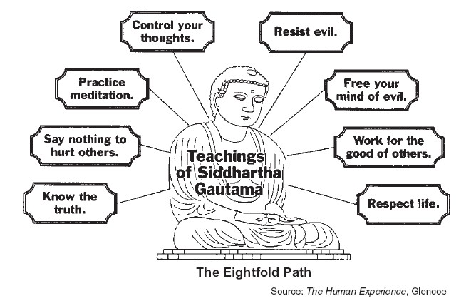

**The Five Precepts**

1. To undertake the training to avoid taking the life of beings.
2. To undertake the training to avoid taking things not given.
3. To undertake the training to avoid sensual misconduct.
4. To undertake the training to refrain from false speech.
5. To undertake the training to abstain from substances which cause intoxication and heedlessness.

**KARMA**: The good or bad actions taken by a person in their lifetime. Karma effects the Buddhist cycle of **REBIRTH**. The good and the bad things that one does in life affect both the current and future lives. The goal is to achieve Nirvana, ending suffering.