Ancient China Play

Based on Historical Facts, but Improvised Conversations

**Teacher:** Catherine Cable

**Subject**: Social Studies or Language Arts

**Grade Level**: 6th

**Time Duration**: 5 days out of a 3 week unit

**Lesson Design**

1) **Standards/Rationale**- 6.6.5 List the policies and achievements of the emperor Shi Huangdi in unifying northern China under the Qin Dynasty.

Additional standards indirectly practiced include: **Creation/Invention in Theater** 6.2.2 Use effective vocal expression, gesture, facial expression, and timing to create character. 6.2.3 Write and perform scenes or one-act plays that include monologue, dialogue, action, and setting together with a range of character types. **Role and Cultural Significance of Theater** 6.3.1 Create scripts that reflect particular historical periods or culture. **Writing Standards** 6.3 and 7.3 a. Engage and orient the reader by establishing a context and point of view and introducing a narrator and/or characters; organize an event sequence that unfolds naturally and logically. b. Use narrative techniques, such as dialogue, pacing, and description, to develop experiences, events, and/or characters. c. Use a variety of transition words, phrases, and clauses to convey sequence and signal shifts from one time frame or setting to another. d. Use precise words and phrases, relevant descriptive details, and sensory language to capture the action and convey experiences and events.

2) **Purpose** (objectives) - Students will work cooperatively in groups to create a PowerPoint and act out their assigned scene(s) from the 6th grade History standard on China.

* Each group will write at least 5 additional lines of dialogue to be incorporated into their assigned scene based on facts. The conversation will be improvised or made up between characters, but all content discussed will be fact.
* Students will add any pertinent information to the “Overview Summary/Additional Facts”. This will be read aloud by a narrator to introduce each scene.
* Students will create a PowerPoint that will be part of the background of the play. The PowerPoint may include music, various sounds, and any relevant pictures (characters, costumes, background, and scenery) that demonstrate the scene they are acting out. The timing of the PowerPoint must be coordinated to match the scene.
* As extra credit, students can create or gather various components for the scene (costume, scenery, or props).

Students will also practice cross curricular activities with Language Arts skills, conducting research, and improving their digital literacy by learning how to:

* Conduct research via the Internet or other mediums
* Save and import digital pictures and sound from the Internet into a PowerPoint
* Work cooperatively with a group
* Write and act out dialogue with proper intonation and pacing
* Learn components of a play including staging
* Demonstrate an ability to take the perspective of another person

3) **Anticipatory Set** (focus) –

* Show pictures of China (gather pictures of characters and architecture in play or pictures of teacher in China, if any)
* Show short YouTube video: <http://www.youtube.com/watch?v=DInxfYjPqKU&feature=related>
* On second or third day of lessons on China, start a KWL chart. This will allow students to offer something more appropriate and in context of what you’re teaching.

4) **Input** –

**Directions:**

1. Make a copy of the play for each student.
2. Read through the play and reiterate that each scene is written, but the student will add additional lines to the scene and create the PowerPoint as background visuals and sound.
3. Read any pertinent curriculum materials and textbook. A suggestion is to read the material aloud whole group highlighting areas that will be in the play. Take Cornell Notes (or give them to students as needed).
4. Assign student groups to a scene (keep groups small, perhaps four to five students). Depending upon class size and ability level, a group can be assigned more than one scene and the same scene can be assigned more than once. There are no female roles, so females can play the male roles as well. A student can play a main role and also a minor role in the same act such as a worker.
5. Optional: Instruct students to get parent signature checking whether or not they can attend play and/ or assist with costumes or props. If you choose to not involve the parent, remove this section from the student directions page.
6. Model how to add dialogue to the play.
7. Play videos while students have the play out to jot down ideas for the PowerPoint: visuals, sound, costume, and props. Show the *Secrets of China’s First Emperor: Tyrant and Visionary* video. Preview video to skip some sections such as burying people alive and chopping off the betrayers head with sword. <http://www.youtube.com/watch?v=yVSvvreJzrA> A second video option is to show the *History International Engineering an Empire*. Preview to skip some sections such as where there is a quick mention that Shi Huangdi kills his mom and lover. Also, skip one word that mentions Zheng He was castrated. <http://www.youtube.com/watch?v=ux5g3yfI-gM>
8. Show information on General Meng Tian as well as all the other dynasties at the website: <http://www.history-of-china.com/qin-dynasty/mengtian.htm>.
9. Show the attached pictures of armor, weights & measure, coins, the Warring States, Shi Huangdi, Meng Tian, etc. A rotating visual of the various dynasty territories can be seen at <http://en.wikipedia.org/wiki/File:Territories_of_Dynasties_in_China.gif>
10. Students will use their textbook, lecture notes, and the Internet to for additional research for their scene.
11. Show how to add pictures and sound into PowerPoint. Find sound clips via the Internet and use a microphone to record the sound. Then, insert this sound into the PowerPoint.
12. Demonstrate how to work cooperatively and act out a portion of a scene. Show how PowerPoint, props, and other members of the class can join in the scene as background warriors or terra cotta soldiers. Print copies of the attached terra cotta mask on a stiff card stock for several members of the class to join in on the appropriate scene as background. Direct students to cut them out and attach a stretchy string so that the mask can be worn. Students should bring gray colored clothes.

**THE PLAY (4 Scenes)**

**SCENE 1**

**Shi Huangdi’s Legalist Style of Ruling**

**Characters: Narrator, Shi Huangdi (Emperor), Li Si (Prime Minister), Han Fei (Han Aristocrat), and a guard(s).**

**Narrator –**Shi Huangdi (his name can be shortened to Qin Shi Huang and his personal birth name was Yíng Zhèng, was king of the Chinese State of Qin from 247 BCE to 221 BCE (officially still under the Zhou Dynasty), and then he became the first emperor of a China from 221 BCE to 210 BCE.

In 221 B.C., China was unified for the first time by Emperor Shi Huangdi. Before this, there was a Warring States period where the 7 kingdoms were fighting for supremacy. He took the throne when he was thirteen years old and become the emperor at age 39. The Warring States period ended when he unified the other six eastern states. Shi Huangdi centralized China with ruthless methods. He was a harsh Legalist ruler. The Legalist philosophy thought that human beings were selfish, evil, and flawed by nature and needed strict laws and harsh punishments to keep them in order. This philosophy is different from Confucianism where it was believed people will follow a good example, so the ruler should be kind and lead by example. In this scene, Shi Huangdi works with his chief advisor also known as his Prime Minister to devise a plan to conquer the 6 warring states.

**Qin Shi Huangdi (speaking to his chief advisor/Prime Minister named Li Si)-** The Qi, the Chu, the Yan, the Han, the Zhao, and the Wei… All of these states are fighting**.** China needs economic and political reform. Li Si, my chief advisor, please tell me your thoughts about how we can unify China.

**Li Si (chief advisor/Prime Minister speaking to Shi Huangdi) –** Emperor, as you know, the State of Qin is in the far west of China, so this geographical position allows us to be isolated and protected from the states of the Central Plains. This is our advantage over the six other warring states. We should annex the neighboring [State of Han](http://en.wikipedia.org/wiki/Han_(state)) to intimidate the other five remaining states. We can then defeat these states one by one.

**Li Si (chief advisor/Prime Minister) –** This is what I’ve come to realize. There is no set standard for honor since everyone's life is different. The values of people are determined by their social status. And like rats, people's social status often depends purely on the random life events around them. And so instead of always being restricted by moral codes, people should do what they deemed best at the moment. The Qin state is extremely powerful, but uniting China will be impossible if all of the other six states unite to fight against Qin. We must keep this from happening.

**Qin Shi Huangdi (speaking to his chief advisor/Prime Minister named Li Si)-** I am impressed by your views of how to unify China. Tell me more.

**Li Si (speaking to the emperor)** – Emperor, we must expel all foreigners from the state to prevent espionage. We must also destroy all histories in the imperial archives except those written by the Qin.

**Qin Shi Huangdi (speaking to Li Si)** - We will implement your proposal. Now go and lure intellects to the state of Qin and have assassins kill any important scholars in other states. To guard against local rebellions, the private possession of arms is now outlawed. All wealthy families from the conquered states must move to the Qin capital, Xianyang.

**Li Si (bowing to the emperor) –** Yes Emperor! My first order will be to capture Han Fei, the prince in the state of Han. He must be stopped because he is an excellent writer with superior abilities that are threat to Qin.

**Qin Shi Huangdi (speaking to Li Si and then everyone exits the stage) –** You are right Li Si. Go capture him!

**Han Fei (member of the aristocracy from the State of Han enters the stage to talk to Li Si) –** Hello Li Si. I am member of the aristocracy from the State of Han. I was asked by the Han king to come here to Qin and resolve the situation through diplomacy.

**Li Si (capturing Han Fei)** – Quick guard, tie Han Fei up and let’s get him to the prison in the capitol.

**Li Si (running in to see the emperor) –** Emperor! Emperor! We have captured Han Fei. We put him in prison. Emperor, I really admire Han Fei’s intellect, but we can’t send him back to HAN because he is a threat to Qin and we can’t give him a job because his loyalty would not be to Qin. His loyalty will always remain with the HAN.

**Li Si (speaking to the emperor) -** My next plan to get rid of him is to keep him in prison and try to convince him to drink poison.

**Qin Shi Huangdi (speaking to Li Si)** – Do as you see fit. Make sure we now conquer the Han!

**Li Si (speaking to the emperor) –** Actually Emperor, we pretty much have conquered them. We just won at the Battle of Changping. This military campaign gave us victory over the [State of Zhao](http://en.wikipedia.org/wiki/Zhao_(state)), and will be remembered as the [most lethal military operation in history](http://en.wikipedia.org/wiki/Most_lethal_battles_in_world_history#Major_operations)!

**Qin Shi Huangdi (speaking to Li Si)** – Excellent Li Si. You are truly dedicated to uniting China and deserved your promotion. Your next priority is to spread the word that works by scholars of different schools must be immediately handed over to the local authorities for burning. If anyone even discussing other books they will be executed. Anyone using ancient examples to satirize contemporary politics will be put to death, along with their families. Any authorities that fail to report cases will be equally guilty. Those that don’t burn the listed books within 30 days will be banished to the north as convicts building the [Great Wall](http://en.wikipedia.org/wiki/Great_Wall_of_China).

**Li Si (speaking to the emperor)** – Are there any books that shouldn’t be destroyed, Emperor?

**Qin Shi Huangdi (speaking to Li Si) -** The only books to be spared in the destruction are books on [war](http://en.wikipedia.org/wiki/War), [medicine](http://en.wikipedia.org/wiki/Medicine), [agriculture](http://en.wikipedia.org/wiki/Agriculture) and [divination](http://en.wikipedia.org/wiki/Divination) or attempt to gain insight into a question. I am the first true Emperor of China. As ruler the only philosophy allowed in China is Legalism. There will be strict adherence to a legal code and absolute power of the emperor. The best way to restore order is to have strong laws and make people obey them, by force if necessary. A ruler must be firm and pitiless. I can trust no one and I will punish anyone who disobeys or performs poorly. “People are submissive to power, and few of them can be influenced by doctrines of righteousness.”

**Scholar (talking to another scholar, disagreeing)** – He is a ruthless ruler that doesn’t understand other philosophies. If Emperor Shihuangdi would only realize that Confucianism would allow a less harsh way to live. With Confucianism, a ruler should be virtuous and kind. Then, the subject will of course be more apt to be loyal and obey the law.

**Qin Shi Huangdi (speaking to Li Si)-** I have been hearing some unforgivable mentioning of the Confucianism philosophy. This is a threat to my authority. A scholar in fact has been spreading these ideas and going against me. Execute him immediately!

Scholar (on one knee begging military for forgiveness)- Please forgive me! I beg for forgiveness. (An official shoots Scholar with a crossbow.)

**Qin Shi Huangdi (walks in the scene and over to body shaking head and says to officials) –**Let this be an example to anyone that goes against me. I now order all Confucianism and Daoism texts to be burned immediately.

**Ruler’s Subjects (quickly scrambling to gather the books and start tearing them up, frantically talking to each other)-** Quickly,

let’s get all these books out of the emperor’s site. Start tearing all of the books up!

**Qin Shi Huangdi (speaking to Li Si) -** I want all 460 scholars buried alive for disagreeing with me and the other 700 can be stoned to death. Let it be known that the approved school of thought is legalism, so follow my laws, or face the consequences.

**SCENE 2**

**Shi Huangdi’s Unification and Accomplishments: Coins/Weights & Measures**

**Characters: Narrator, Shi Huangdi (Emperor), Li Si (Prime Minister), Mint Master**

**Narrator –** After Shi Huangdi unified China, he made one currency called the banliang coin. It was a round coin with a square hole in the center. All previously used money made out of bronze were obsolete. Some people believed that the earth was square and heaven was round, so some believe that Qin Shi Huangdi made this design to show himself as a link between heaven and earth. We can’t know for sure, but some also think that this design was just for function, so a whole stack of coins could be slid onto a square-shaped rod to be filed down all at the same time.

He also created standard weights and measures for the entire empire and standardised written Chinese characters to produce a script that could be read everywhere. Before this, Chinese words could be written in a variety of ways. This allowed him to govern and control the unified empire more easily and these characters are still used today.

**Qin Shihuangdi (speaking to Li Si, the Prime Minister) -** Scene starts out Round coins with holes, scale for weights and measure,

**Qin Shihuangdi (throwing knife money as he speaks to Li Si**)- This knife money must go. It’s heavy and cumbersome. Money shouldn’t be different shapes and sizes. I want the currency of the different states to be standardized.

**Li Si (speaking to Qin Shihuangdi) -** What do you suggest emperor?

**Qin Shihuangdi (speaking to Li Si)** – We need something easier to carry. This knife money weighs up to 15 grams and it’s sharp.. Hmm, we need to keep the same idea with having a hole to strap it onto belts or rings. Let’s make it smaller and round with a hole in the middle.

**Li Si (speaking to Qin Shihuangdi) –** I will have a prototype made, emperor. We can call our new money the banliang coin, which means half ounce.

**Qin Shihuangdi (speaking to Li Si)–** That is the perfect name. Everyone in China will be required to use it.

**Qin Shihuangdi (speaking to Li Si In a victorious and conquering tone, and walking out of the room) -** This coin will be a symbol showing that the earth is square and heaven is round. It will be a symbol that I am a direct link between heaven and earth.

**Li Si (speaking to the mint master sitting next to molds making the coins) –** Mint Master, are the coins made yet?

**Mint Master (speaking to Li Si in a scared voice)** –Yes Li Si. I think the emperor will be very happy. Come look at these. I’m just taking them out of the moulds that they were cast in. I just need slide this whole stack of onto a square-shaped rod to file them all own at the same time.

**Li Si (speaking to Mint Master as he walks out of the room with several coins in his hand) –** The emperor will be pleased.

**Li Si (walks into see Shi Huangdi)** – Here are the new banliang coins, Emperor. With your efforts to standardize coins and weights and measures, there will be more efficient commerce.

**Li Si (speaking to Qin Shihuangdi) -** Emperor, I know of something that will further unify China… A standardize script throughout all the conquered regions. We will get rid of all the regional scripts to form one language, one communication system for all of China!

**Qin Shihuangdi (speaking to Li Si) –** Yes, we should have one font as well for this uniform written language. This will allow for greater communication and implementation of policies. With this script scholars can share information to a greater number of people and spread our culture. With this, our Chinese script can be read everywhere!

**SCENE 3**

**Shi Huangdi’s Unifying Northern China: The Great Wall**

**Characters: Narrator, Shi Huangsi, Meng Tian (General), Workers Building Great Wall, Women Sifting Dirt & Pounding Grain**

**Narrator -** More than 2,000 years ago, China’s First Emperor, Shi Huangdi, built a great wall to protect his land from invaders from the north. Around 300,000 captured soldiers and military recruitments lived, worked and died in remote areas of the empire to complete this huge project. The Great Wall of China we know today is built on the foundations of the Qin wall. Before the use of bricks, the Great Wall was mainly built from packed earth, stones, and wood.Meng Tian was a general of the [Qin Dynasty](http://www.history-of-china.com/qin-dynasty/index.html) who helped fight against the Xiongnu and in building the Great Wall of China.

**Shi Huangdi- (concerned and talking to Meng Tian, Army General)** - It is going to be impossible to wipe out northern tribes. I think the best way to secure China is to actually secure China from the inside.

**General Meng Tian (asking Shi Huangdi)** – What are you proposing?

**Shi Huangdi- (speaking to Meng Tian)**- We are going to connect all the walls in the north that were built by all the fighting territories.. This will be the Great Wall of China that will keep out all northern invaders as well as to keep the Chinese people locked in.

**General Meng Tian (speaking to Shi Huangdi) -** Do you realize that this will take years, maybe even 10 years, and this is more than 5000 miles of tough terrain.

**Shi Huangdi- (impatiently replying to Meng Tian loudly**) Yes, get 1 million people in China’s labor force to build this wall!

**Shi Huangdi- (speaking to Meng Tian)**- I want the wall wide enough for 6 soldiers to ride side by side. It must be 15 to 30 feet thick and reaching heights of 25 feet. I want the southern side facing China defended by parapet (wall to protect soldiers) and the northern facing the barbarians crenulated (having a scalloped edge). Gather everyone you can and force them to work on this wall. Once it is complete, armies will be stationed along the wall as our first line of defense from invading nomadic tribes in the north. Set off signal fires as a warning.

**General Meng Tian (speaking to Shi Huangdi) –** Yes emperor. I will also station soldiers at each arch.

**Shi Huangdi- (speaking to Meng Tian)- Excellent! And if anyone complains or tries to run away, they should be killed.**  **(both exit the stage)**

**General Meng Tian (now at the Great Wall, speaking to workers) –**We need the wall to have a wooden frame. Every 700-1000 feet, put a wood poll to make it stable. Fill it with gravel, reeds, water, and clay. Use a log to pound the earth.

**Workers (some workers carrying a basket on back to bring supplies, some with hoes or shovels, and others are pounding the dirt and making the wall frame).**

**General Meng Tian – (dragging a new slave worker onto stage) -** Overseer, make sure he gets branded with the Qin word in red and then put him to work building the wall.

**Worker 1 (workers whispering amongst themselves)** – I wonder what he did?

**Worker 2 (workers whispering amongst themselves)** – I heard that he didn’t pay his taxes. You know taxes have gone up 20 times and people just can’t pay it. As it is, about 1/5 of China’s labor force has worked on this wall. I bet about a quarter of them have died now and are buried right here in the wall.

**Worker 1 (workers whispering amongst themselves)** – I can’t wait until the wall is finished so that I can go home back to see my family.

**SCENE 4**

**Shi Huangdi’s Mausoleum**

**Characters: Narrator, Shi Huangdi (Emperor), Li Si (Prime Minister), Several Terra Cotta Soldiers, Artists Assembling Terra Cotta Soldiers, Overseer, Enemy Attackers.**

Terra Cotta masks **(Scan mask),** several people being buried alive and stoned to death. Cup with Shi Huangdi drinking mercury.

**Narrator –** The First Emperor, Shi Huangdi, became more and more afraid of death. He wanted desperately to be immortal and live forever. He would drink mercury, which we now know is poisonous and most likely is what caused the emperor's death rather than preventing it. Just in case the elixirs did not work, in 215 B.C., at age 13, the Emperor also ordered the construction of a huge tomb for himself with flowing rivers of mercury, cross-bow booby traps to keep out plunderers, recreations of the Emperor's palaces, and an 8,000 clay soldier army to protect him in the afterlife with real chariots and weapons. The part of the tomb housing the coffin and the burial has not been excavated yet to see what’s really inside. Better technology needs to be developed to keep the artifacts and any paint from disintegrating.

**Li Si ( talking to an overeseer ) –** What is this? Someone etched the words "The First Emperor will die and his land will be divided" onto the stone. Oh, keep it hidden from the emperor or he’ll take it as another sign that something bad is going to happen. The meteor that fell was already a bad sign.

**Shi Huangdi- (enters the mausoleum area being carried in a chariot) –** What is it that you are hiding? Bring it here**! (The overseer brings the stone to the emperor and bows).**

**Shi Huangdi- (says angrily to Li Si and the overseer)**-I know people are plotting against me to have me killed. Who wrote this sign? Since nobody will fess up to this crime, everyone in the vicinity will be executed. The meteor itself must be burned and then pounded into powder. I also want all historical records of my reign destroyed. If they don’t comply, they’ll suffer the consequence with their life. **(The emperor in his chariot is carried off the stage).**

**Li Si (goes to see Shi Huangdi) –** Emperor, we’ve burned alive more than 400 people, including your own son. Where do we stop?

**Shi Huangdi- (speaking to Li Si)**- We’ll stop once everyone complies. Now, I want you to build my mausoleum to keep my memory alive.

**Li Si (speaking to Shi Huangdi) –** What would you like it to have?

**Shi Huangdi- (speaking to Li Si**) - It must have more than 8,000 army terracotta soldiers to guard me in the afterlife that are about 6 feet tall weighing 600lbs. I want them facing north in the direction of the barbarians to protect me. Each soldier is to look like a real individual, with unique facial features. There should be terracotta horses with real chariots and bronze weapons. The tomb must be 400 feet tall and taller than the Great Pyramid of Egypt!

**Li Si (speaking to Shi Huangdi) –** Yes Emperor.

**Shi Huangdi- (speaking to Li Si**) – I also want every ethnic group represented in each terra cotta soldier’s face. This will symbolize the unity of China. **(Everyone leave the stage).**

**Worker 1 – (Everyone busily assembly terra cotta soldiers in mausoleum and several standing as if assembled already) -** This is going to take us years to complete this many soldiers out of clay.

**Worker 2 – (speaking to Worker 1) –** Shh, be quiet or the overseer will have your head. We done enough for the day, so let’s go get some sleep.

**Enemy Attackers (attackers run into the mausoleum. They’re wearing black armor and carrying torches) –** Hurry into the mausoleum! We must destroy all these terra cotta soldiers. Smash it to pieces! **(The push over the statues and break several).**

**Overseer (walking with overseer into mausoleum to find the destroyed terra cotta soldiers)** – Oh no, Li Si! Shi Huangdi won’t stand for this! He will be furious!

**Li Si (speaking to overseer panicked**) – Quick, let’s get everyone here to start fixing everything broken. We can’t let the emperor see the damage.

**Shi Huangdi- (enters the mausoleum days later being carried on his chariot and speaks to Li Si) –** Why is it taking so long?

**Li Si (speaking to Shi Huangdi) –** Emperor, we had to repair the damage from the invaders that tried to destroy the mausoleum. We have more than 700,000 laborers working to build your burial mausoleum. We are finishing adding trap doors and trying to get enough mercury to create the flowing river for protection. However, this project has nearly bankrupted the country.

**Shi Huangdi- (speaking to Li Si) –** You have been building my mausoleum for 37 years now. You must complete the mausoleum by next year. We must also go after the barbarians that tried to destroy my mausoleum.

**Li Si (speaking to Shi Huangdi) –** Yes Emperor. The interior of the mausoleum is now completed with a recreation of a garden with the mercury river running through it. Trees were fashioned with leaves made from green jade and the vault is inlaid with chips of lapis lazuli to look like the night sky

**Shi Huangdi- (speaking to Li Si) –** Excellent job Li Si. To prevent the craftsmen from divulging the secrets of the mausoleum, all the workers are to be buried. **(all the workers get on their knees and are covered with a brown blanket or paper to represent dirt).**

5) **Modeling** (show me) –

If available, use a Visualizer or SmartBoard to project the textbook or Internet so that the whole class can see the lesson.

1. Read and discuss project directions.
2. Teacher will demonstrate how to read a passage on the Internet or watch film clip and turn it into dialogue in the play.
3. Instruct how to safely research on the Internet and identify historically accurate webpages.
4. Demonstrate how to save a pictures/sounds and import it into PowerPoint
5. Demonstrate acting out a few lines in a scene with the PowerPoint as the background.

6) **Guided Practice** (follow me) –

Students could be in front of their own computer to follow along and practice. If available, use a Visualizer or SmartBoard to project the Internet and PowerPoint so that the whole class can see the lesson.

1. Demonstrate ways to research on the Internet.
2. Show how to search for and save images to import into their PowerPoint
3. Read material aloud and model how to write dialogue.

7) **Checking For Understanding** (CFU) –

1. The project handout will be turned in by each student for grading. There will be a group grade and individual grade. It will indicate what each person contributed in the group.
2. The teacher will allow time for in class practice of the play to determine if each student is contributing and offer any additional guiding.
3. Students will take a weekly or end unit quiz of concepts discussed.

8) **Independent Practice** –

Students will use their textbook, lecture notes, and the Internet to find information on their assigned role in the scene. Each student will gather photos of the character, music, sound, and/or scenery to be included in a group PowerPoint, which will be timed to play accordingly as the scene is acted out.

9) **Assessment-**

1. The project will be assessed using the rubric provided on the directions.
2. Students will take a weekly or end of unit quiz.
3. The play will demonstrate group cooperation, coordination, and understanding.

**10) Adaptations & Extensions:**

* Small packets with curriculum information can be simplified for student reference.
* A list of websites can be supplied for student research.
* Difficulty level can be increased or decreased by adjusting or eliminating the quantity of dialogue lines to be added to the script.
* For student comfort levels in performing the play, the audience can be adjusted smaller to include just fellow classmates, parents, or other smaller groups of classes.
* Extra credit opportunities can be offered for adding additional lines of dialogue, bringing props, or creating a costume to wear.
* Group should be mixed ability and heterogeneous.
* Assist in assigning roles to ensure each student can participate in some manner
* Learn and sing the Chinese Dynasty song each day as introduction. Give dynasty song as a handout and show YouTube video clip to demonstrate.
* Add to the play to include additional 6th grade China standards.

Student Name: __________________ Parent Signature:_____________________ Date:____________

*Please circle whether or not you will be able to attend the play* ***[YES or NO)*** *or assist with gathering props or costume(s)* ***[YES or NO].***

[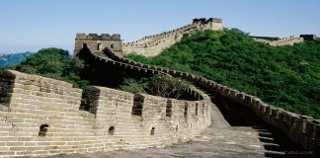](http://1001arabian.net/tourist/bigimages/Great%20Wall%20of%20China.jpg)**Ancient China Play**

**Location & Date of Play:______________**

**Directions & Rubric:** To gain a better understanding of standard 6.6.5, the policies and achievements of the emperor Shi Huangdi in unifying northern China under the Qin Dynasty, students will work with a group on an assigned scene to finish the scene and act it out. **Each student will:**

* Write at least 2 additional lines of dialogue to be incorporated into their assigned scene based on facts. The conversation will be improvised or made up between characters, but all content discussed will be fact.
* Add any pertinent information to the “Overview Summary/Additional Facts”. This will be read aloud by a narrator to introduce each scene.
* Create 1 or more slide(s) for the group PowerPoint that will be part of the background of the play. The PowerPoint may include music, various sounds, and any relevant pictures (characters, costumes, background, and scenery) that demonstrate the scene they are acting out. This timing of the PowerPoint must be coordinated to match the scene.
* As extra credit, students can create or gather at least one component for the scene (costume, scenery, or props).

**/5 POINTS Parent signature obtained at the top.**

**/5 POINTS Write down your assigned scene topic: ____________________________________________  
/15 POINTS Write down ideas that you could use as a visual, sound, or prop in scene or PowerPoint.**

**_______________________________________________________________________________________________**

**/30 POINTS Attach a separate paper and copy down all of the dialogue in your scene. Highlight and/or circle what you added. Each student must add at least two lines of dialogue based on facts or additional summary details/facts to be read by narrator to introduce the scene.** Example: Shi Huangdi *(angrily orders his**chief architect):* Link the Great Wall to keep out northern Mongolian invaders.

**/25 POINTS Print PowerPoint page(s) that** you **created (1 or more slides per student). PowerPoint must be rehearsed to go along with the scene. It will be used as a background. It might include any of the following: pictures, sounds, props, silent movie clips, and music.**

**/25 POINTS Student was prepared and rehearsed for play. Spoke line with appropriate eye**

**contact, loudness, intonation and pacing. Made effort to dress for the part.**

**/25 POINTS Student worked cooperatively with group and used class time appropriately.**

**Extra Credit**

**/15 POINTS Parent contributed to play and/or attended.**

**/15 POINTS Student brought in extra components for the scene (costume, scenery, props)**

**/130 TOTAL POINTS**

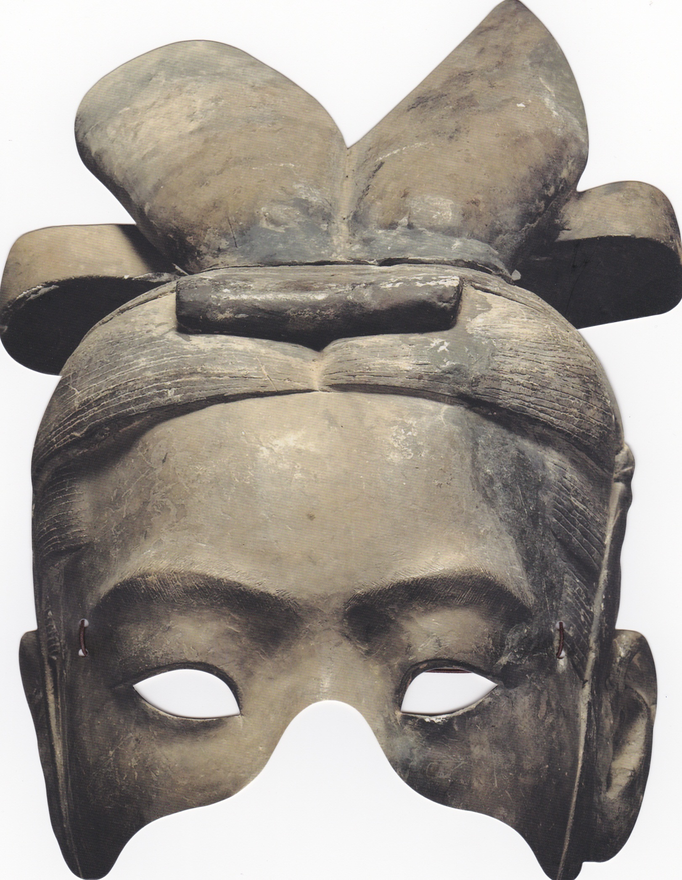

Emperor Shi Huangdi

[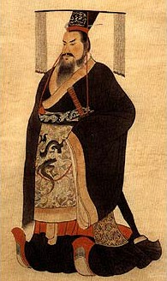](http://en.wikipedia.org/wiki/File:Qinshihuang.jpg)5 catty weight for weighing food and groceries

[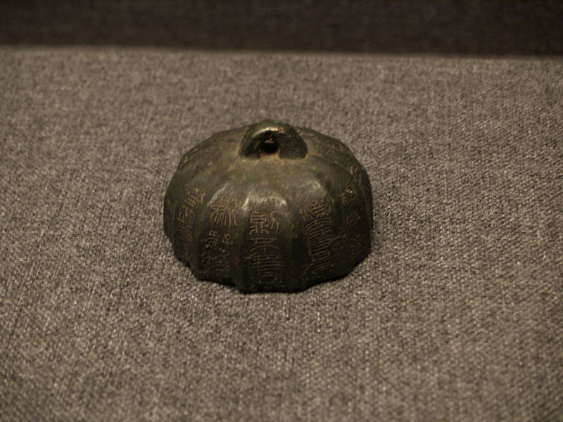](http://upload.wikimedia.org/wikipedia/commons/e/e9/Qin_Shi_Huang_weight.JPG)

[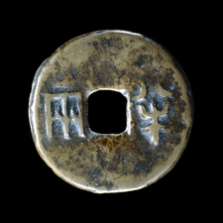](http://www.britishmuseum.org/explore/highlights/highlight_image.aspx?image=k136992.jpg&retpage=17196)[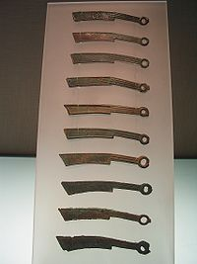](http://en.wikipedia.org/wiki/File:Yan_State_Coins.jpg) banliang coin knife money (used before banliang)

Qin soldier helmet

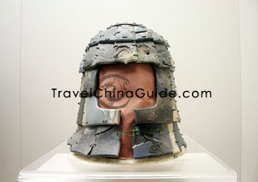Suit of Armor

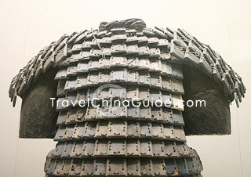

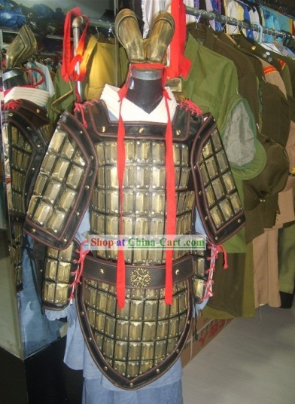

**Li Si General Meng Tian**

[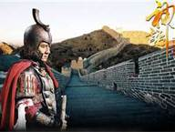](http://www.bing.com/images/search?q=general+meng+tian&view=detail&id=B4E3005DB5789421E9204B291036DC9A5AEC1D50&first=1)[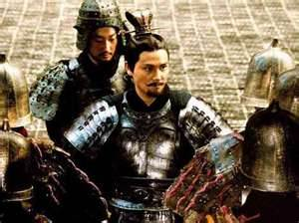](http://www.confuciusonline.com/wp-content/uploads/auto_save_image/2010/10/082348pCM.jpg)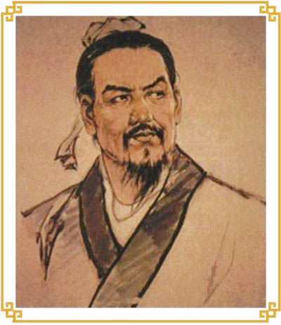

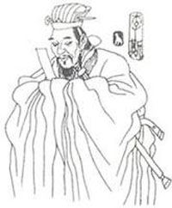

**Great Wall of Warring States Period**

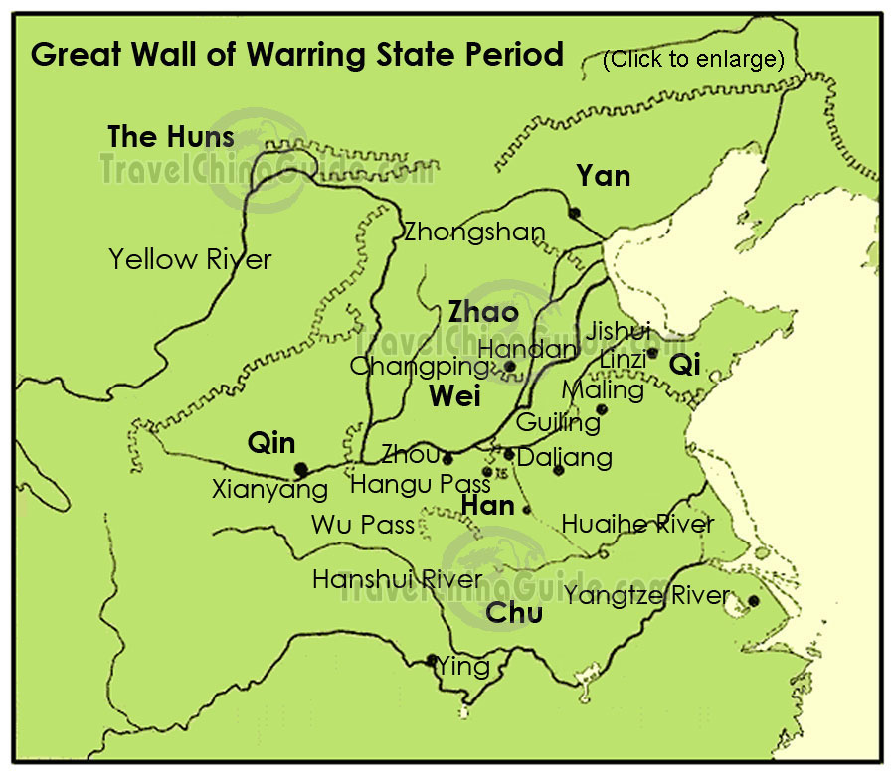

[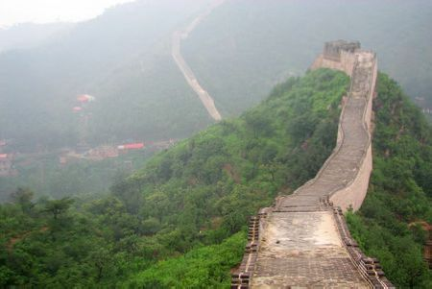](http://www.chinatravelcompass.com/beijing/img/attractions/great_wall/huanghuacheng/450/huanghuacheng_great_wall_1.jpg)

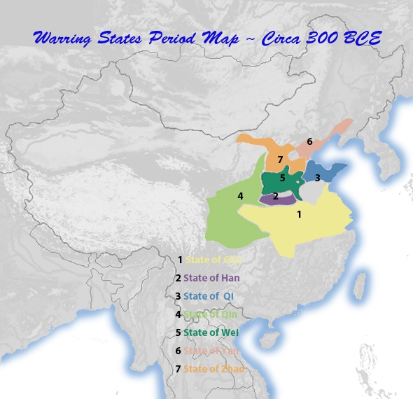

[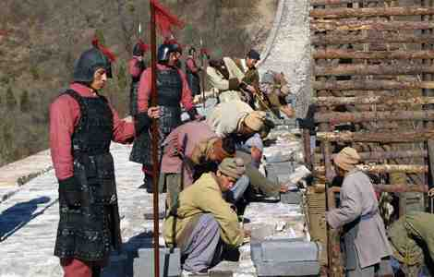](http://www.china-mike.com/wp-content/uploads/2011/01/great_wall-construction-workers2-small.jpg)

[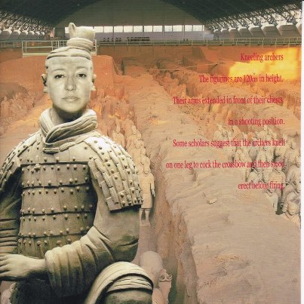](http://www.facebook.com/photo.php?fbid=4210514155057&set=a.1139266935796.21883.1651094579&type=1&relevant_count=1)[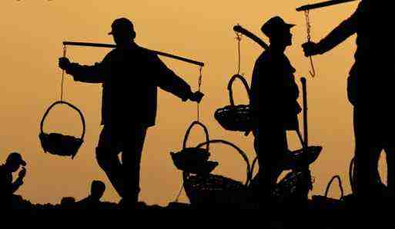](http://www.china-mike.com/wp-content/uploads/2011/01/great-wall-workers.jpg)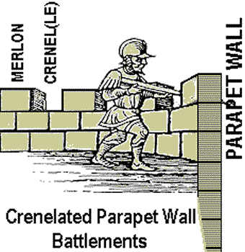

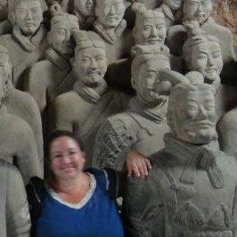

**Bibliography**

AllHistories. "Engineering an Empire - Ancient China 1of3." *YouTube*. History International, 14 Sept. 2009. Web. 23 Sept. 2012. <http://www.youtube.com/watch?v=ux5g3yfI-gM>.

AllHistories. "Engineering an Empire - Ancient China 2of3." *YouTube*. History International, 14 Sept. 2009. Web. 23 Sept. 2012. <http://www.youtube.com/watch?v=hSOdv-2InF8>.

AllHistories. "Engineering an Empire - Ancient China 3of3." *YouTube*. History International, 14 Sept. 2009. Web. 23 Sept. 2012. <http://www.youtube.com/watch?v=c5LDHCkG0oQ>.

"Bronze Banliang Coin." *British Museum -*. N.p., n.d. Web. 23 Sept. 2012. <http://www.britishmuseum.org/explore/highlights/highlight_objects/cm/b/bronze_banliang_coin.aspx>.

"Great Wall of China (wall, China)." *Encyclopedia Britannica Online*. Encyclopedia Britannica, n.d. Web. 23 Sept. 2012. <http://www.britannica.com/EBchecked/topic/243863/Great-Wall-of-China>.

"Imperial China, The Qin Unification (221-206 Bc)." *The Qin Unification (221-206 Bc)*. N.p., n.d. Web. 30 Sept. 2012. <http://www.countriesquest.com/asia/china/history/imperial_china/the_qin_unification_221-206_bc.htm>.

"Meng Tian-First General of Chin." *Mengtian in Qin Dynasty, Qin Shihuang, History of Ancient China*. N.p., n.d. Web. 30 Sept. 2012. <http://www.history-of-china.com/qin-dynasty/mengtian.htm>.

Neji107. "Qin Shi Huang Di." *YouTube*. YouTube, 31 Mar. 2008. Web. 23 Sept. 2012. <http://www.youtube.com/watch?v=DInxfYjPqKU>.

PIETRASZE. "Secrets Of The First Emperor." *YouTube*. National Geographic, 15 Apr. 2011. Web. 23 Sept. 2012. <http://www.youtube.com/watch?v=yVSvvreJzrA>.

"Shi Huangdi." *Wikipedia*. Wikimedia Foundation, 29 Sept. 2012. Web. 30 Sept. 2012. <http://en.wikipedia.org/wiki/Shi_Huangdi>.